Medieval English Literature
Dana Tsai 487200635
Tobey Hsieh 487200271

Cindy Chien 487200245

Architecture

Church
Apart from the manor, the church’s role went far beyond religion to be the center of community life. Church parishes were usually the manor villagers. The church occasionally served double duty as the priest’s residence and often was built to be defended in times of trouble.
Early Norman churches were built without aisles, but with a central tower, and as a whole of cruciform plan, shaped like a cross. Medieval parish churches were usually plastered inside and out to illustrate Biblical scenes for illiterate people. However, very little survived today. Before the Great Plague of 1348-50, the growing population needed more space inside parish churches, so many churches added aisles then. The most remarkable parish churches of the late medieval period are “wool churches” built by newly rich class of local merchants thriving on England’s wool trade.
The basic architectural characteristics of the Saxon parish churches are: rectangular east end, side entrance (usually on the south side), and a west tower. Churches were often located on pre-Christian sites of spiritual significance, taking advantage of people’s existing devotion to a particular place. Churches are always oriented so that the main altar is at the east end of the church, facing Jerusalem and the rising sun. Even if the altar end of the church is not literally in the east, it is called the “east end.”

Monastery
Monasteries were the other main form of church presence. They were self-sufficient communities where monks or nuns live a simple life of prayer and work. Often built closely to churches, monasteries were just like a miniature society with almost all necessary facilities, for instance, bake house, workshops, and even cemetery.

Romanesque Style
Art in the middle ages was inseparable from religion and inevitably full of spiritual symbolism and meaning. The purpose of art was to awe and inspire the viewer with the grandeur of God.
At the beginning of the Norman era the style of architecture that was in vogue was known as Romanesque, because it copied the pattern and proportion of the architecture of the Roman Empire. The chief characteristics of the Romanesque style were barrel vaults, round arches, thick piers, and few windows. General speaking the Romanesque churches were heavy and solid, carrying an air of solemnity and gloom.

Gothic Style
In 12th century France, a novel style of architecture emerged. At the time it was called simply “The French Style,” but later Renaissance critics, shocked at the rejection of classical architectural style, sarcastically called it “Gothic.” This name refers to the Goths, a tribe ransacked Rome during 3rd to 5th century and accordingly deemed as barbarian.
Very different from heavy Romanesque architecture, Gothic architecture is light, spacious, and graceful. Crusades helped to learn new architectural techniques from the Arab world, which then resulted in innovations such as the pointed arch, ribbed vault, and the buttress. Gothic architectures, especially cathedrals, are in general gorgeous and richly decorated with ribbed vaults, rose windows, stained glasses, flying buttresses, spires, pinnacles, statue-columns, gargoyles, and flamboyant patterns.

Ⅴ. Styles

A. Romanesque
＊ Durham Cathedral
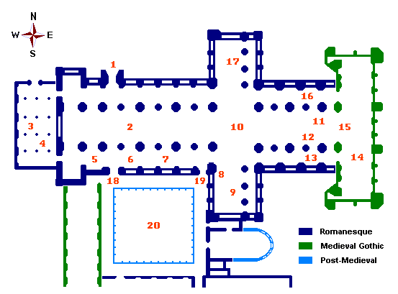
★ The Plan:

The Plan demonstrates the typical Medieval churches and
cathedrals, most of which were built in the form of a cross.

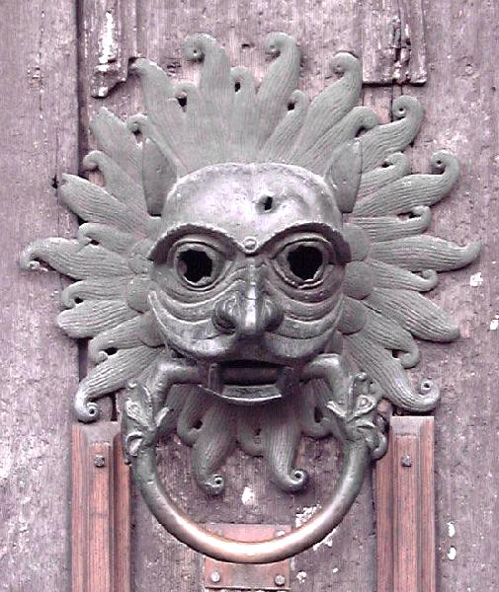
★ The Sanctuary Knocker:
Durham Cathedral is used to be the home for Benedictine
monks and the sanctuary for those in need. Anyone who
claimed for sanctuary would knock on the Sanctuary
Knocker and then be brought to the Monastery, where he
would stay for at most 37 days and choose trial or exile.
The Sanctuary Knocker we see is actually the copy. The
original one is now in the Cathedral's museum.
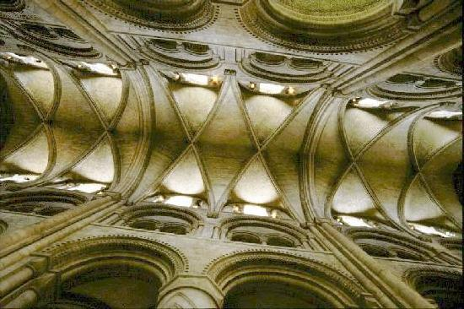

- The Nave:

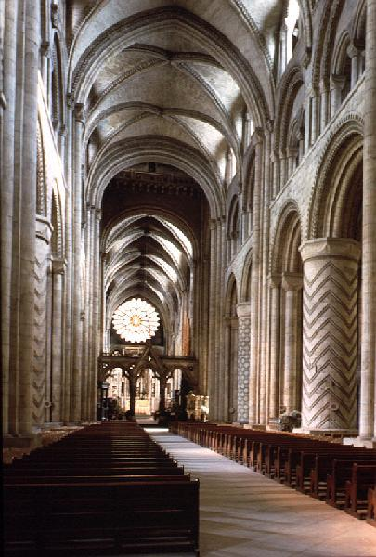
(The roof of the nave)

The roof of the nave is what we called "ribbed vault." It's the innovation in Romanesque style and would be widely used in Gothic cathedrals.

- Durham Monastery
Through the Monk's door or the Prior's door we'll come to Durham Monastery. It was funded in 1083 and was the home and workplace for Benedictine monks.

★ The Cloister ★ Dormitory
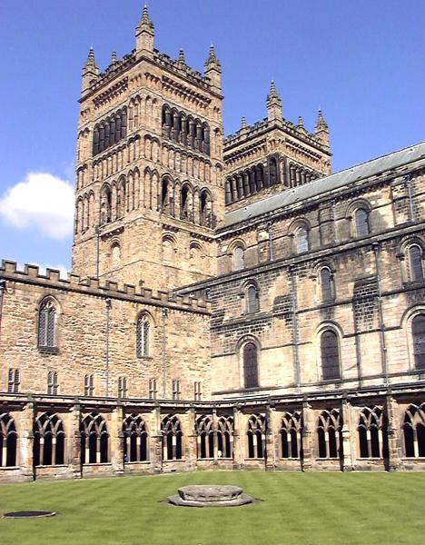
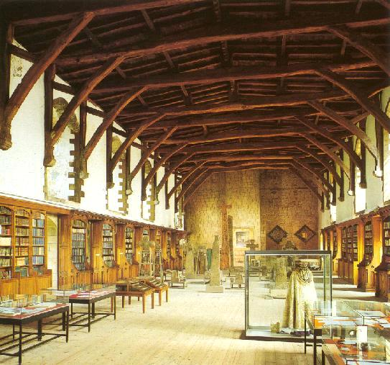
★ The Garth: The Garth is the pass way to the monastery.

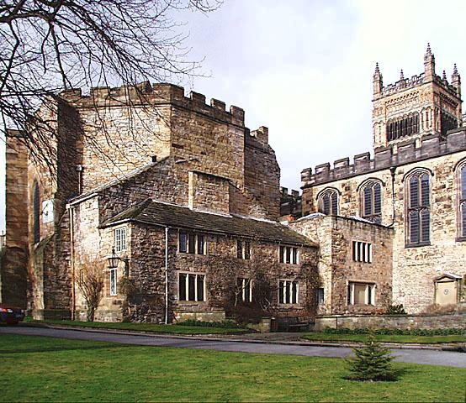

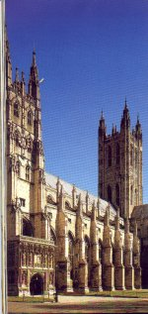
B. Gothic
- Canterbury Cathedral

Funded in A. D. 597, Canterbury Cathedral has been
rebuilt many times.

(The Roof)
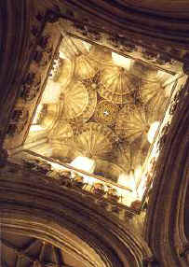
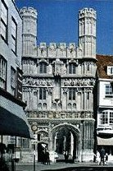

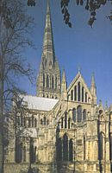
- Salisbury Cathedral

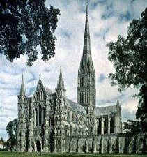
Salisbury Cathedral was built in 1220 and it took 95 years fo finish this great work. Therefore the cathedral is actually a mixture of different architectural styles.

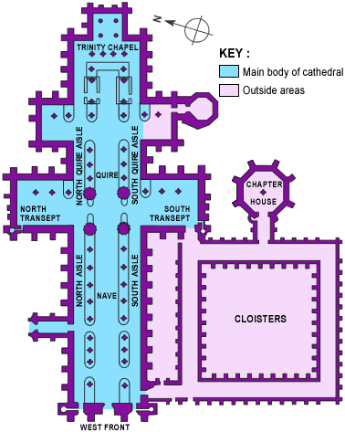
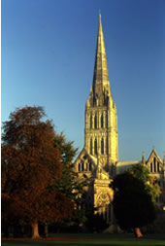
- The Spire:
The spire is the
tallest medieval
structure in the
world; it's 404
feet high.

- Cloucester Cathedral

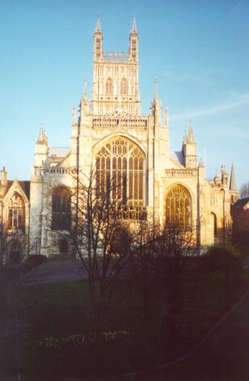
- Barrel Vault: It eliminates the distinction between bays and the space is enclosed under a uniformly curved and patterned surface. This is one of the important features of Gothic style.

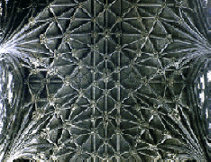

★ Fan Vault:
What makes fan vault so special is that the ribs are no longer structural; they are carved on the surface of thin stone plates, which are fitted together to form the fans.
- Stained Glass: This is also one of the main features of
Gothic style.
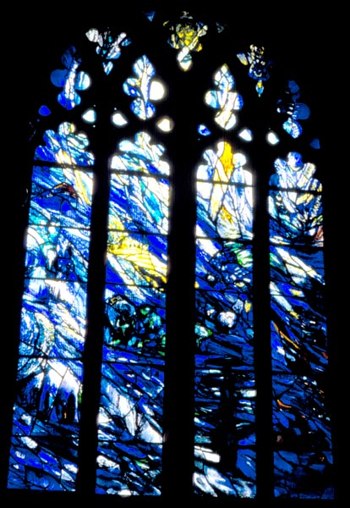

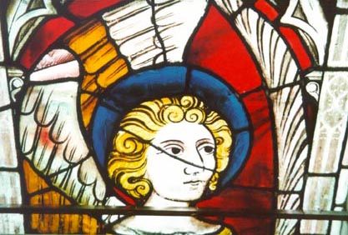

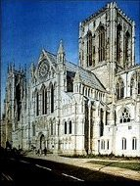
- York Minister
York Minster was built between 12th and 15th century and is now the largest Gothic church in England.

★ The Plan
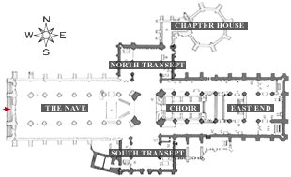

- North Transept: The polished Purbeck stone columns and the central
Wooden vault makes it typical of English
Gothic style. The Five Sisters Window in
★Tracery: It holds the largest expanse of glass in the world.
the middle contains over 100,00 pieces
of glass and is now dedicated as a
memorial to the women who lost their
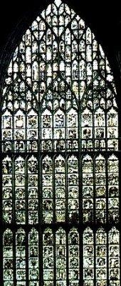
lives in the two world wars.

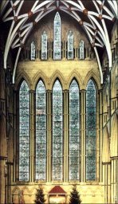

Ⅵ. Castle
Most buildings are built for purposes, and so are castles. Castles appeared in Medieval Europe in the Age of Feudalism. A feudalism society had a shape as a pyramid. On the top of it was a king, who owned lands. Below the king were several major landholders, who promised to give military services to the king in return for the lands. Those landholders let out lands to tenants, this process went repeatedly down the pyramid to the bottom, the knights. Due to the fact that the society was not always peace in Medieval time, defensible bases were needed, and so castle appeared.

A. First Castle
First castle emerged in the 11th century when the Norman congested England, and brought Feudalism. To secure their ruling power over England, they found defensive base inevitable and so constructed many of them. These first castles shared two major features. Despite that they were made of earth and timber, they all had motte and bailey. The motte is a large conical mound with a flat top. Usually they were either made of natural hillocks or raised by digging a ditch around its site and heaping up the result soil. The bailey is a simple enclosure with its ditch. Most motte and bailey castles had the motte at one end of the bailey and separated from it by its ditch. Both mound and enclosure were defended by the ditch and an earthen bank behind the ditch, topped with timber stockade. “Where practicable, the ditches were filled with water and in some instances had a raised bank in front as well as behind, known as a counterscarp which may have had a hedge of thorns or briars planted on it.” On the mound, there was a timber tower, where was the residence of the castle’s owner and his family. There was also a hall within the bailey, which is the place people gather for meal and activities.
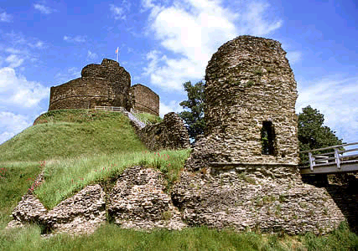
(Launceston Castle is a model of motte and bailey castles)

B. After 12th Century
Later in 12th century, feudalism decayed. They needed to protect themselves from each other than ever. The purpose of a castle was more focused on attacking and besieging. On the same time, the old material of timber was facing its major drawbacks of vulnerable to fire and perishable. Therefore, motte and bailey castles were gradually replaced by walls of towers of stone. In addition to this, to add defense to castles, the mound and enclosure was also replaced by the tower and enclosure. In this period, castles could be categorized into two forms – shell keep and tower keep.
Shell keeps, were mostly circular in shape for they were formed simply by replacing timber stockade around the motte with a stone ring wall. The Windsor Castle was an example of a shell keep.

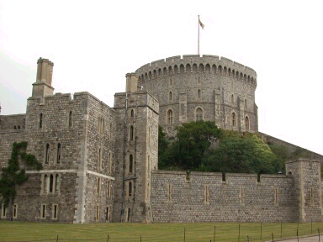
Tower keeps, were rectangular in shape.
Usually, the walls rose from a splayed or battered plinth which protected the base of the building. Each wall was strengthened with shallow, flat buttresses being taken up about the battlements to form turret.
There were usually small rooms in the walls, like kitchens, guardrooms, or bedrooms. In the corner turrets, there were spiral stairs leading to various floors. And Rochester Castle is an example of tower keep.
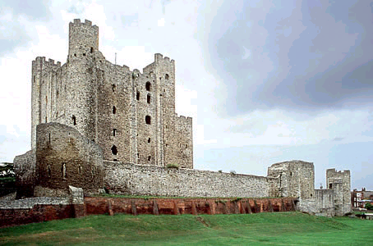
Inside the keep, a cross wall divided it into different rooms and storeys. The only entrance to the keep was an external staircase built against the outer wall. Instead of windows, there were arrow-slits and loopholes in the lower levels. Even in the upper levels, windows were pretty small. (The picture below is the inside of Rochester Castle.)
