TILLIE OLSEN
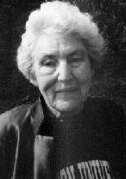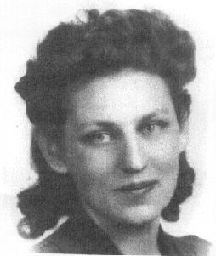
TILLIE OLSEN -- author of Tell Me a Riddle, Silences, and Yonnondio.
-- Born in 1912 or 1913, she began writing in the 1930s, while raising four children and supporting them with a series of low-paying jobs in the 1930s through 1950s. (image & info source: http://mockingbird.creighton.edu/NCW/olsen.htm; http://endeavor.med.nyu.edu/lit-med/lit-med-db/webdocs/webdescrips/olsen11948-des-.html)

“I Stand here Ironing”
The story starts with the question: , "I wish you could manage the time to come in and talk with me . . . She's a youngster who needs help."
How does the mother respond to it?

- Explaining the difficulties which make her daughter alienated from her:
- Describing the difficulties she had during Depression: those of a young mother who goes by the book; of a working mother whose husband leaves them behind. p. 113-14;
e.g. social background: 1) pre-relief, pre-WPA world of the depression.
(WPA -- The Works Progress Administration was one of the many programs initiated by the federal government under President Franklin D. Roosevelt to combat the devastating effects of the Great Depression.
Relief – The Emergency Relief Appropriation Act of 1935, which makes WPA possible. Source: http://www.indiana.edu/~liblilly/wpa/wpa.html )

2) convalescent home – protection of ill children which actually separates them from human or familial contact.
e.g. the mother’s lack of smile (115); the daughter’s plea for attention pp. 115, nightmares 116
- Describing the goodness of the daughter, and her changes.
- beautiful baby;
- her alienation from the mother;
- her pressure of socialization 117-18; (appearance, language and speed of learning)
- her physical problem: asthma (Emily vs. Susan)
- Assert her daughter’s identity for her. “She leaves her seal.” Pp. 119 -
- Style: As the question torments her "back and forth with the iron," her thoughts go the same way, interrupted by housework. (p. 119)
- Ending: the ending: ‘She will find her way.’

