Charlotte Mew
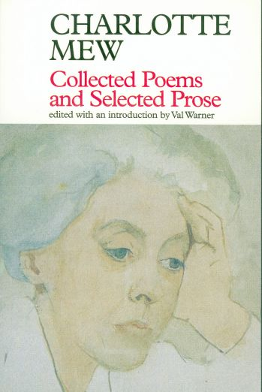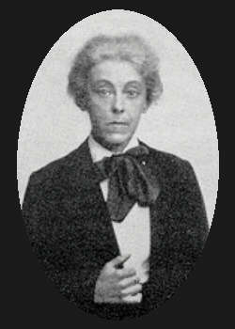
--The traumatic issues Mew grappled with during her childhood—death [of three brothers], mental illness [of one brother and one sister], loneliness, and disillusionment--became themes in her poetry and stories.
-- "The Farmer's Bride," in the Nation in 1912, established her literary reputation, but it did not win her money. She and her sister Anne had to move from their mother’s house, which caused Anne to fall ill. Anne was diagnosed with cancer in 1926 and died the following year. Charlotte gradually sank into despair. Becoming delusional, she entered a nursing home in 1928 for treatment, but ended up committing suicide there later the same year.
-- She is thought to have had lesbian tendencies though there is no evidence of any sexual relationships with other women.
Source: Contemporary Authors Online. The Gale Group, 2001.

“The Quiet House”
--Pay attention to the frequent mentioning of death in this poem; the role of the Father, the cousin’s friend.
-- images of color red and white, of fire and ‘the things.’
-- How do we characterize the speaker? How is she related to the house?

Virginia Woolf
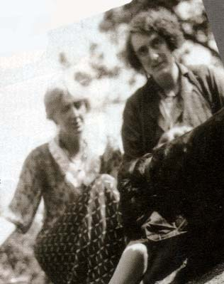
Virginia Woolf and her lover, Vita Sackville-West
- When she was 13, Virginia's mother died suddenly of influenza--an event that triggered her first mental breakdown (some now believe that she suffered from manic depression).
- Stella, the older half sister, took over running the household but she, too, died suddenly two years later, shortly after returning from her honeymoon.
- Then, in 1904, Virginia's father died after struggling for two years with abdominal cancer, and she had a second breakdown. She tried to commit suicide by throwing herself out a window, but it proved too close to the ground.
- in 1906, yet another tragedy struck: Her beloved brother Thoby died at 26 of typhoid fever following a trip to Greece. The next year, Vanessa married art critic Clive Bell, leaving only Virginia and Adrian together.
- Woolf celebrated the affair with Sackville-West in her 1928 novel Orlando
- 9 novels, 1 play, 46 short stories, and more than 14 volumes of diaries and letters as well as numerous essays, portraits, reviews, and memoirs.

"A Sketch of the Past" (1939)
- self-conscious as a writer
"As a great memoir reader, I know many different ways. But if I begin to go through them and to analyse them and their merits and faults, the mornings . . . will be gone. So without stopping to choose my way, in the sure and certain knowledge that it will find itself, or if not it will not matter—I begin: the first memory." (64)
- first memory – “red and purple flowers on a black background—my mother’s dress.”
Second memory – “"If life has a base that it stands upon, if it is a bowl that one fills and fills and fills—then my bowl without a doubt stands upon this memory. It is of lying half asleep, half awake, in bed in the nursery at St. Ives. It is of hearing the waves breaking, one, two, one two, and sending a splash of water over the beach; and then breaking, one, two, one, two, behind a yellow blind. It is of hearing the blind draw its little acorn across the floor as the wind blow the blind out. It is of lying and
hearing this splash and seeing this light, and feeling, it is almost impossible that I should be here; of feeling the purest ecstasy I can conceive." (64-65)
- color of her early memory: green, pale yellow, silver.

- Non-being pp. 70 -71
As a child then, my days, just as they do now, contained a large proportion of this cotton wool, this non-being. ...Then, for no reason that I know about, there was a sudden violent shock; something happened so violently that I have remembered it all my life. I will give a few instances. ... The second instance was also in the garden at St. Ives. I was looking at the flower bed by the front door; "That is the whole", I said. I was looking at a plant with a spread of leaves; and it seemed suddenly plain that the flower itself was a part of the earth; that a ring enclosed what was the flower; and that was the real flower; part earth; part flower. It was a thought I put away as being likely to be very useful to me later.

Descriptions of the mother, whom obsesses her till the completion of To the Lighthouse:
- sensory/visual details → her attention focused on her mother
- her identification with her mother (laughter, finger size) (textbook 92)
- the mother’s private moments (textbook 93)
- her description of her vs. not knowing her as a ‘person.’ 93-95
- her death

