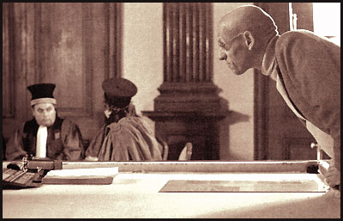
Michel Foucault (1926 - 1984)
Discourse, Power and Subjectivity
Outline
A. Starting Questions
B. General Ideas
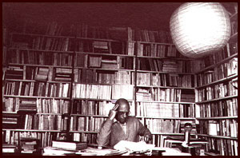
C. Discourse – Definition and Distinction
(From Language to Discourse; Discourse & Ideology)
D. Power and Knowledge (Truth)
-- Discipline & Punish
-- The History of Sexuality; Subject and Subject Position)
E. Ethics
F. Foucault: Influences of and Criticism by Feminism

A,. Starting Questions : Discourse, “Truth” & Power
1. Discourse
-- What is discourse and how is an individual (such as an author or a reader) related to a discourse? What are the examples Foucault gives in discussing “the bringing into discourse of sex”?
-- What issues of authorship can support Foucault’s idea of author as an author function? Copyright? Originality?
-- Do you agree with Foucault’s argument that --"nothing has any meaning outside of discourse“?
-- What discourse, or its “the regime of truth,” makes the following statements valid?
- Madness is a mental illness.
- Masturbation causes sexual impotence.
- sodomy → gay → homosexual → queer → 怪胎
2. Power
-- What are the examples of society’s carceral system? How does it function? Does our consumer society only have carceral system as a way of controling and conditioning subjects?
-- Do we question disciplinary powers such those of the teachers’, judge’s and doctors’? Or to what extent should they be questioned?

B. Foucault: General Ideas
Three periods:
1) Archaeology of knowledge-- rules and strategies for formation of subject-positions, knowledge and episteme. (e.g. “Man” as a product of modernity.)
“What is an Author” – 1969 –transitional article
2) Genealogy of power/knowledge – extends his discussions to a variety of institutions and non-discursive practices; mutual support of power and knowledge.
e.g. Discipline and Punish, History of Sexuality.
3. The Care of the Self
a. From technologies of power to technologies (techne)of self: (p. 78)
--the issue of power and agency → later Foucault, concerns with the constitution and transformation of self.
(p. 79)
http://www.literacy.unisa.edu.au/jee/Papers/JEEVol6No1/Paper%206.pdf
b. In Foucault’s own words – a versatile equilibrium between techniques of domination and techniques of the self.
p. 143 Foucault Religion and Culture. Ed. Jeremy Carrette 162.
Qtd http://mypage.siu.edu/hartmajr/pdf/jh_fouccirc_03.pdf

Technologies of the Self (the governmentalized form) vs. Techniques of the Self = Aesthetics of the Self (self-transformation, to distance oneself from oneself.)
C. Central concerns – Besides Power, Knowledge and Discourse (or “games of truth” --
a. The "other": historical fragments, accidents & interruptions (vs. official history);
madness (vs. reason), sickness (vs. health), crime (vs. law);
abnormal sex (vs. normal sex).
b. constitution of subjectivity—which includes i). technologies of self: subjectification/objectification of individuals:
-- production: of those bodies of knowledge which appear to be sciences ; (e.g. the speaking subject in linguistics; the “authors” in literature)
-- differentiation: those practices which install a division of subjects of differing qualities; (e.g. the sane vs. the mad)
-- discipline: knowledge and techniques by means of which individuals turns themselves into subjects. (e.g. sexualized subjects)
ii). techniques (or aesthetics) of self

D. Discourse: Definition and Distinction
I. Discourse is "a group of statements which provide a language for talking about ...a particular topic at a particular historical moment." ( discursive practices within institutions → the carceral or medical system)
Three major procedures in discursive formation over time.
- Definition & Prohibition → defining statements & Rules about the “sayable” and “thinkable”
- Division and rejection; → subject positions; exclusion of other statements
- Opposition between false and true → Authority/Power of knowledge (Truth)

II. Discourse and Language
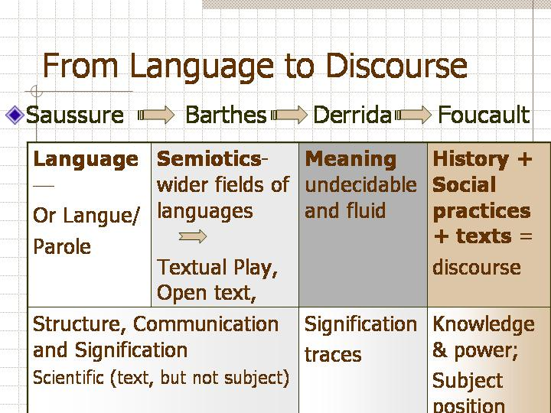

III. Discourse and Ideology
-- Discourse operates through disciplinary and discursive practices, so it is less connected with the economic.
-- Ideology can be closer to discourse when it is not just ideas (but with material basis), and when it supports power relations (but not economic relations in a stricter sense.)

D. Power and Knowledge/Truth
I. power—disciplinary and productive (new forms of power which is not just repressive or violent)
– both repressive, controlling and productive
-- not just top-down (not sovereign power); it circulates, working in multiple direction like “capillary movement.”
e.g. the operation of power in a hospital –exertion of power through spatial arrangement, the doctor’s examination, the posters, pamphlets, the different examination room, registration system, pharmacy, insurance co., etc.
e.g. from The History of Sexuality – discourse of sex which includes birth control, confessional, control/education of children’s sexuality (through spatial arrangement, morning examination and teaching pp. 28), the investigation of a half-wit who plays “curdled milk” (a dirty game) with some village girls (31).
-- discipline and surveillance through various rituals, examination and documentation; e.g. scholastic tests, medical examinations and histories, employment interviews, etc. (ref. Rouse 96); all the digital ID numbers (ref. Nicholas Rose); confession (HS)
-- the “swarming” of disciplinary mechanism (e.g. penoticism → society as a carceral system)
a.[the mechanisms of the disciplinary establishments] certain tendency to become 'de-institutionalized', to emerge from the closed fortresses in which they once functioned and to circulate in a 'free' state; the massive, compact disciplines are broken down into flexible methods of control, which may be transferred and adapted.
b. centres of observation disseminated throughout society
→ interlocking disciplines of psychiatry, criminology, pedagogy, and clinical medicine (Rouse 113).
-- the art of human body – docile body “Discipline and training can reconstruct it[target of control] to produce new gestures, actions, habits and skills, and ultimately new kinds of people.”
«What was then being formed was a policy of coercions that act upon the body, a calculated manipulation of its elements, its gestures, its behaviour. The human body was entering a machinery of power that explores it, breaks it down and rearranges it. A ‘political anatomy’, which was also a ‘mechanics of power’, was being born; it defined how one may have a hold over others’ bodies, not only so that they may do what one wishes, but so that they may operate as one wishes, with the techniques, the speed and the efficiency that one determines. Thus discipline produces subjected and practiced bodies, ‘docile’ bodies.”

II. producing “Truth” – with a discursive formation sustaining a regime of truth. New forms of human knowledge get produced as new forms of human control are designed. → Knowledge produced through normalizing judgments
-- Power and knowledge as dynamic relationships rather than things possessed.
“"Power is not something that is acquired, seized, or shared, something that one holds onto or allows to slip away; power is exercised from innumerable points, in the interplay of nonegaltarian and mobile relations Power relations are both intentional and non-subjective." (HS 94)

III. biopower and governmentality --
Biopower is not just discipline but regulation on a global scale, it is ‘the power to make live. Power won’t make die, but it will regulate mortality.’ (source)
(O’Leary p. 29) mechanisms of power:
a) Before the 18th century-- a ‘sovereign’, ‘deductive’ power; power operates negatively, by deduction [e.g. the king’s right to take life”; a right of seizure…”
b) since 18th century -- a life-administering’ ‘bio-power’—it operates by “addition” and augmentation. It has become a positive influence on life; one that ‘endeavours to administer, optimize and multiply it”; but all within an orientation towards ‘subjecting it to precise controls and comprehensive regulations” (HS 137)
governmentality – 1) “the ensemble of institutions, procedures, analyses, reflections, calculations and tactics’ which allows the exercise of what we could call bio-power; 2) the process of executing such power to make it pre-eminent in Western societies.

Ref. Rouse, Joseph. "Power/Knowledge." The Cambridge Companion to Foucault. Ed. Gary Gutting. Cambridge University Press, 2005.
“Biopower and Biopolitics” http://www.generation-online.org/c/cbiopolitics.htm
IV. HS – (ref. O’Leary 24) “operates by inciting, cajoling, producing, normalizing and ‘governing’ sexuality, rather than by repressing, silencing and denying it.”

IV. More on Discipline and Punish
Main purpose -- not so much the “birth of the prison” as “disciplinary technology”
4 Parts: 1. Torture; Torture
-- soul – “born out of methods of punishment, supervision and constraint”; “the prison of the body” (29-30)
-- torture -- part of truth-production mechanism (35-37)
2. Punishment -- gentler forms: public works and incarceration
3. Discipline
1). Docile Bodies (135-69)
-- The aim of disciplinary technology is to forge “a docile body that may be subjected, used, transformed and improved” (136)
2). The Means of Correct Training (170-194)
--”Discipline ‘makes’ individuals; it is the specific technique of a power that regards individuals both as objects and as instrument of its exercise” (170)
3). Panopticism (195-228) Penopticon 敞視監獄
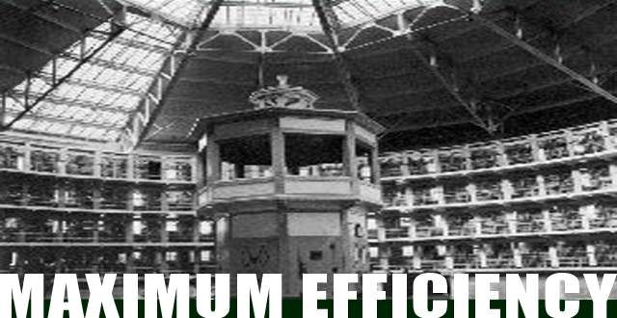
A circular building with the central control tower → control internalized.

Two principles: permanent visibility to the center; lateral invisibility -- > insures the
automatic functioning of power.
(Predecessors: 1. leper: exclusion and separation; 2. control of plague town with permanent system of registry, a disciplinary project of hierarchy, surveillance, observation and writing p. 198; )
Discipline defined: “Discipline may be identified neither with an institution nor with an apparatus; it is a type of power, a modality for its exercise, comprising a whole set of instruments, techniques, levels of application, targets; it is ‘physics’ or an ‘anatomy’ of power, a technology” (215).
Disciplinary Society: “one can speak of the formation of a disciplinary society in this movement that stretches from the enclosed disciplines, a sort of social ‘quarantine’, to an indefinitely generalizable mechanism of ‘panopticism.’ Not because the disciplinary modality has replaced all the others, but because it has infiltrated the others, sometimes undermining them, but serving as intermediary between them, linking them together, extending them and above all making it possible to bring the effects of power to the most minute and distant elements. It assures the infinitesimal distribution of the power relations.. (216)

Part 4: Prison --
1) Based on the model of Mettray prison farm.
(textbook 1637) p. 1639 It is at the limit of strict penality. It is a prison, but also something else. It can serve as an alternative to ‘paternal correction.’
a. five models: family, army, workshop, school and judicial model.
b. way “The least act of disobedience is punished and the best way of avoiding serious offenses is to punish the most minor offences very severely.”
c. the teachers and judges there serve as technicians of behavior, engineer of conduct, orthopaedists（整型外科醫師） of individuality.
d. (textbook: 1638) It is related to other forms of supervision: medicine, general education, religious direction.
-- e.g. the birth of scientific psychology. (so that knowledge serve to support discipline).

2) The carceral -- forms of discipline which exercise over individual a perpetual series of observation and modes of control of conduct;
-- Carceral power opens up the entire fabric of society to a normalizing regulation. (Miller 200-01)

examples of continuity and extension of the carceral: p. 1640

3) carceral system—examinatory justice (vs. inquisitorial justice) with judges of normality everywhere.
p. 299 The continuity of the institutions themselves, which were linked to one another (public assistance with the orphanage, the reformatory, the penitentiary, the disciplinary battalion, the prison; the school with the charitable society, the workshop, the almshouse, the penitentiary convent; the workers’ estate with the hospital and the prison). . . .The ‘carceral’ with its many diffuse or compact forms, its institutions of supervision or constraint, of discreet surveillance and insistent coercion, assured the communication of punishment according to quality and quantity; . . .
III. History of Sexuality I
I. The Repressive Hypothesis – Discourses on sex proliferate ad infinitium, while sex is exploited as ‘the secret.’
1. A steady proliferation of discourses concerned with sex – not baldy jokes, but disciplinary discourses (e.g.
-- confession: where sex is not names, but details described; a diversion from flesh to “the stirring of desire;
--scandalous literature such as My Secret Life
-- installment of apparatus and other mechanisms to produce greater quantity of discourses: medical discourse (24) → sex is administered and managed.
e.g. birth control pp. 25-26
e.g. children’s sex – a. silence as an element within; b. architectural design c. doctors + schools+ family (example on p. 29 of a festival where students were asked questions about sex in public)
--p. 29 discursive formation: Ithe 18th century, it has multiplied the forms of discourse on the subject; it has established various points of implantation for sex; it has coded contents and qualified speakers.
-- p. 30 expansion or “a regulated and polymorphous incitement to discourse” (34): from medicine (nervous disorder) to psychiatry to criminal justice→ “all those social controls…which screened the sexuality of couples, parents and children. . . “
e.g. the case of the half-wit (31)
II. The Perverse Implantation –The inclusions of the perverse, or fruitless, sex on the margins.
Three major codes (up to the end of the 18 c): canonical law, the Christian pastoral and civic law, which
-- were all centered around the matrimonial relations.
-- made no distinction between violation of marriage laws and deviation from them.
Discursive explosion (since the 19th c): 1) centrifugal movement with respect to heterosexual monogamy. 2) scrutinizing the sexuality of children, mad men, women and criminals … (38-39)
3) separation of the illegal from the “unnatural”

Four Forms of Power (not interdiction)
1. devices of surveillance installed by doctors and educators to combat children’s onanism (children’s solitary habits) but they penetrate every aspect of their lives.
2. incorporation of perversions and a new specification of individuals
3. Power as constant and attentive presence, intertwining with pleasure
4. devices of sexual saturation → inciting of multiplying mechanism, but not inhibition: e.g. 19th c family household (46) Other areas of sexual saturation—educational and psychiatric institutions such as school dorm, the army base, gym.
Power (biopower) –multiply sexuality
“The implantation of perversions is an instrument-effect: it is through the isolation, intensification, and consolidation of peripheral genders that the relations of power to gender and beauty branched out and multiplied, measured the body, and penetrated modes of conduct. And accompanying this encroachment of powers, scattered genders rigidified, became stuck to an age, a place, a type of practice.... Beauty and power do not cancel or turn back against one another. They are linked together by complex mechanisms and devices of excitation and incitement.” (48)

Example: Performative Genders, Perverse Desires: A Bio-History of Thailand's Same-Sex and Transgender Cultures http://wwwsshe.murdoch.edu.au/intersections/issue9/jackson.html
“the Thai project to renormativise 'perverse' [wiparit] genders and 'deviant' [biang-ben] sexualities only came into being after the existence of the diverse array of new identities and cultures had been exposed to public view by the sensation-seeking Thai press.[9] The Thai biomedical project was itself incited into being by the presence of the new identities, and drew upon Western knowledges in an attempt to put the genie of proliferating sexual and gender diversity back into the bottle. This is the converse of the situation that Foucault described for Western Europe, where it was the rise of new biomedical knowledges, amongst other factors, that in turn incited new sexualised identities into being.”

E. Ethics
Ref. TIMOTHY O'LEARY. Foucault and the Art of Ethics. Continuum, London & New York, 2002.
(31) Volume 1 “deals with ethics because it deals with the ways we are constituted and constitute ourselves as subjects; and the tasks of understanding the historical forces which have made us the kinds of individual that we are is, for Foucault, one of the most important tasks of ethics.
→ journey back to Greece: “in Classical Greece and imperial Rome individuals were concerned with their sexual conduct not because this field was subject to social or religious control, nor because it was a field where the truth of their subjectivity would be discovered, but because it was one of the fields where one could (and should) practice the art of transforming one’s life into a work.” (37)
(p. 11) Ethics as subjectivation or self-constitution as subjects: For Foucault, “ethics is not a field of rules, principles or precepts, it is the field of self-constitution as subjects. [It] consists of the set of attitudes, practices and goals by which we guide our moral self-fashioning.”
(pp. 13-14) Aesthetics of the Self: 1) a form of relation of self to self which is neither a hermeneutic relation, nor a relation that attempts to fix a pre-given or natural identity, but is a relation which sees the self as a task, as something which needs to be continuously worked on. → aesthetics –techne (techinique)
2) the kind of self we want our work of self-transformation to result in.. → aesthetics – aestheticism

F. Foucault: Influences of and Criticism by Feminism
Criticism by (Ref. Bristow pp. 189 - )
Sandra Lee Bartky – Foucault ignore gender and sexual difference.
e.g. docile bodies of whose?
Kate Soper –a. “the sexual ethics that Foucault strongly admires in both ancient Grek and Greco-Roman civilization depends on forms of domination” (Bristow 190)
Self-care – masculine, and primarily self-mastery and authorial self-creation.
b. curdled milk – She agreed with Aeon Huang!
“…one is left wondering if the game of ‘curdled milk’ was both bucolic and inconsequential for the little girl” (192).
Ann Laura Stoler To Foucault, …”racism is a consequence of that ‘class body’ in the making.”…”bourgeois bodies were constituted as racially and relationally coded from the outset.” (Stoler qtd Bristow 193)

Two influences (Ref. Sawicki):
1) analysis of discursive control of women and women’s bodies (e.g. Susan Bardo on anorexia)
2) analysis of the possibility of forming counter discourse (e.g. Judith Butler)

Ref. Sawicki, Jana. “Queering Foucault and the subject of feminism.”
The Cambridge Companion to Foucault (Cambridge Companions to Philosophy). Gary Gutting
Sexuality. (New Critical Idiom) Joseph Bristow. Routledge, 1997.

