The Uncanny
Questions:
1. What are your examples of the uncanny?
Main Idea:
-- Uncanny: both strange but secretly familiar. Or “what was once heimlich:”
Reasons: a. one meaning of heimlich is the concealed, kept from sight, and thus unheimlich—the secret and hidden but has come to light. “What is Heimlich thus comes to be unheimlich.”
b. un – token of repression.
-- Although Freud discusses the uncanny both in terms of the return of the repressed from the psyche and that of the intellectually surmounted, his focus in on the return of the repressed. His examples of the uncanny include: castration fear, double (which reveals first our narcissism and then our confrontation of death), recurrence, involuntary repetition (e.g. compulsion to repeat), coincidences, the physically fragmented, life after death or being buried alive.
-- Artist has more means to create the uncanny than in real life. Though we can ignore the uncanny in some genres (e.g. Snow White’s being brought back to life), the uncanny as the return of the repressed is more resistant and remains as powerful in fiction as in real life.

I. Definition.

heimlich-- "familiar," "homely," to "secret and hidden" to "dangerous and dreaded"

→ unheimlich (p. 934)

II. Two kinds of the Uncanny

Cessation of a belief and then the return of the old, discarded beliefs: Many people experience the feeling [of the uncanny] in the highest degree in relation to death and dead bodies, to the return of the dead, and to spirits and ghosts.... --animism, magic and sorcery, the omnipotence of thoughts, man's attitude to death

Return of the repressed (p. 950)-- involuntary repetition and the castration complex comprise

III. Example of the Uncanny –“The Sandman”

Freud’s interpretation and clues 938 –939

(1) castration fear-- the example of Offenbach's Tales of Hoffmann. "The Sandman": tear the kids' eyes out to induce sleep. → the castrating oedipal father

This story is "uncanny" because Nathaniel's fear of the "sandman" is at once incomprehensible and strangely familiar: it partakes of the unconscious.

IV. The other kind of the Uncanny: double

the pre-oedipal stage of primary narcissism

-- double as (1) reflection, (2) superego and (3) shadow

double: an insurance against destruction of ego;

An agency of self-observation

A creation dating back to a very early mental stage

Repetition compulsion 941 -

Repetition

Compulsive repetition of traumatized patient

Vs. Fort-da game (Beyond the Pleasure Principle)

(the motive of this repetition remains to master the unpleasant situation. The boy compensates his powerlessness by placing himself in the position as agent.)

Death drive → stasis; repetition = return to a prior state and re-finding of the lost wholeness.

Vs. sexual drive →disruption and transformation; repetition = detour and deferring finality

V. The role of literature

Pp. 950

The uncanny as it is depicted in literature: more fertile province than the uncanny in real life, for it contains the whole of the latter and something more besides, something that cannot be found in real life.

profound modification → the uncanny in fiction

→ (1) a great deal that is not uncanny in fiction would be so if it happened in real life;

(2) there are many more means of creating uncanny effects in fiction than there are in real life.
Conclusion
Though we can ignore the uncanny in some genres (e.g. Snow White’s being brought back to life), the uncanny as the return of the repressed is more resistant and remains as powerful in fiction as in real life.

“The Uncanny and its Poetics.” Speaking Desires can be Dangerous: The Poetics of the Unconscious. Elizabeth L. Wright. Malden, MA: Blackwell, 1999.

Main Idea: the uncanny is defined in terms of representation
- “has the effect of destabilizing language” (18).
- (for Lyotard) the uncanny emerge as “the unpresentable” (24)

- Surrealism is not an illustration of psychoanalysis (Adorno)
-- No one dreams like that.
--“In Surrealist art, objects are most carefully chosen and placed, in just this space, next to another object just this size”;
-- its strategies: “use of collage and montage, which enable images…to be juxtaposed in patterns of discontinuity. It is this which gives Surrealism its shock value, provoking that sense of ‘where have I seen this before?’, the Heimlich (homely and familiar) combined with the unheimlich (hidden and secret).” (20)
-- Adorno: the shock effect: comes from “that twilight state between a schizophrenic sense of the world split into parts, either chopped up or threatened to merge, and the apparent autonomy and self-sfficiency that these parts assume. (20-21)

Example (1) of the uncanny in Surrealist painting

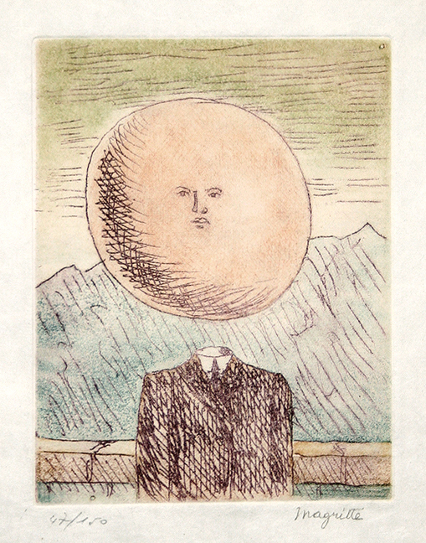
L'Art de Vivre, 1968
( The Art of Living )
www.pasqualeart.com/magritte/magritte_51739.html (from http://www.pasqualeart.com/magritte/index.html)

p. 21 (The co-presence of Heimlich and unheimlich…The sun as king-image is suddenly turned into a man or father-image by means of a small face in the middle of its large sphere. …But the sun also looks like a head that has been severed, as if it were the fearful realization of a repressed wish. At the very moment when this wish is gaining expression, it emerges as a threat, in the fixed stare of the face. (21-22)

- The uncanny is “a projection of our inner fears onto the external, creating objects of love and hate.” (23) Cixous points out that Freud provokes the unheimlich effect” because his essay “is disrupted by repeated images of dismembered bodies, effects of the unconscious which reveal anxiety about death, and anxiety about his own priority as the discoverer of the unconscious. (24)

- 3. (for Lyotard) the uncanny emerge as “the unpresentable” (24)

Example (2) of the uncanny in Surrealist painting – on representation
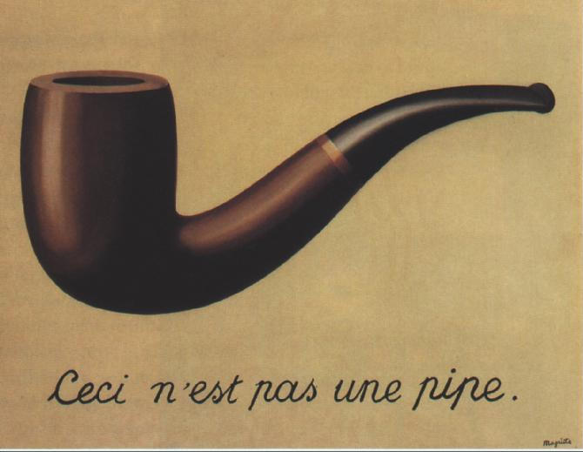
(Rene Margritte. 〈影像的背叛〉“The Treachery of Images" source: http://en.wikipedia.org/wiki/Image:MagrittePipe.jpg)

ceci = this = language “This phrase is not a pipe”

- Example: Wolf Man –afraid of insects and animals
His dream: a man is tearing off the wings of an “Espe” (Wespe or wasp the unheimlich) and SP → the childhood memory of seeing a large butterfly with yellow stripes and large wings,

