Paul Chen (26th Oct. 2004) and Kate Liu (March 4, 2011)

“The Signification of the Phallus” (1958)
by Jacques Lacan (1901-1981)
Pre-reading Questions
1. What is “subject,” as is discussed by contemporary theories?
2. Do you agree that the Father’s authority is associated with language and interdiction(禁止)?
3. Do you agree that our learning of language is a process of castration and fragmentation (splitting)? And that our desire is drifting from one object to the next, and that ultimately we desire a kind of pre-Oedipal unity?
Do you know the meanings of the following key words/expressions?
- The Imaginary, the Symbolic and the Real
- S/s -- Subjectivity, split and meconnaissance (misrecognition), a constantly moving chain of signifiers (sliding of signifying chain)
- “The unconscious is structured like a language.”
- Desire, Demand and Need
- The Other and objet petit a
- The Other -- (a) language as a structure (as in structural linguistics); (b) the symbolic order as the legal fabric of human culture (in accordance with Lévi-Strauss’s anthropology); (c) the Freudian unconscious as reformulated by Lacan in his widely promoted return to its original, subversive signification.

- The gaze and the look
- ‘L-Schema’

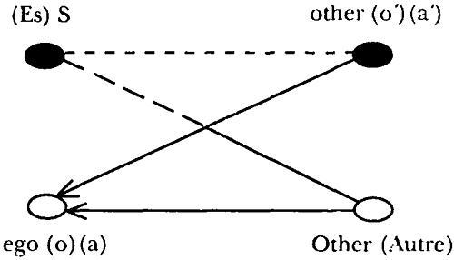

Ideal ego

Lacan: “S, his ineffable and stupid existence; a his objects; a‟, his ego, that is, his form as reflected in his objects; an A, the locus from which the question of his existence may arise from” (p. 550, his italics).
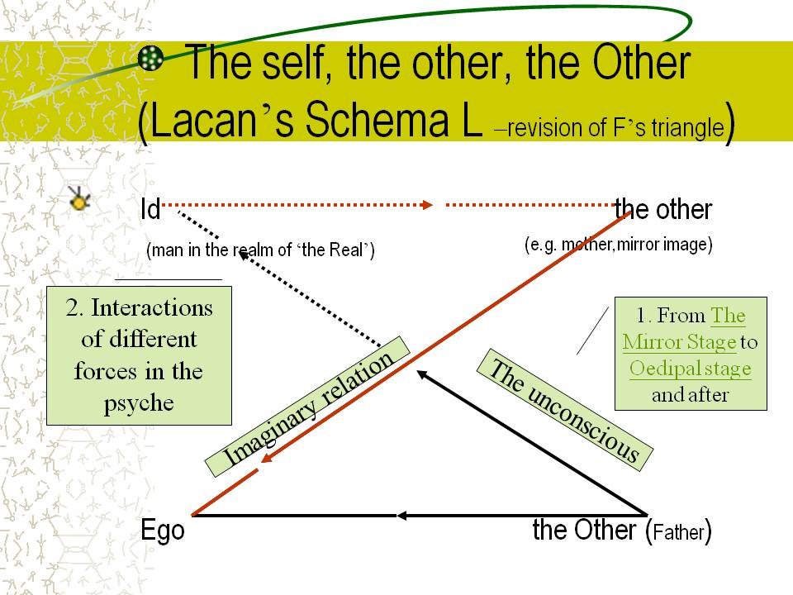
"I think where I am not, therefore I am where I do not think."
3. How do you interpret this painting?
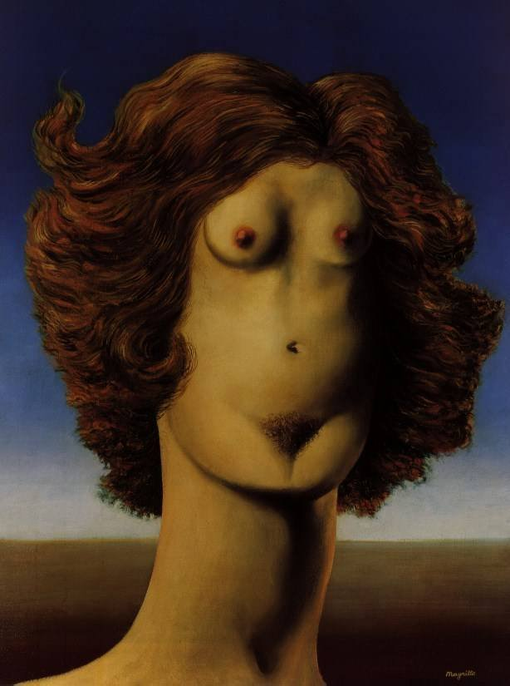
Rape 1945: Collection Mme. Rene Magritte, Brussels, Belgium
http://www.humanitiesweb.org/human.php?s=g&p=c&a=p&ID=1065

Lacan’s views of love:
Why is there love? Because there is no sexual relationship.
- Love is the mirage that fills out the void of the impossibility of the relationship between the two sexes.
Why impossible? Unity with the other and in one’s self.
- Demand = a demand for the unity of the self and the other “Love consists in a series of …demands for the proof of the other’s commitment. The proofs sought from the other are impossible, imaginary tests of love.” (G 132)
Examples: Woman: conflict between being a sexual object and a subject demanding recognition.
- As a sexual object, she “paints/shaves/dyes/diets/exercises her body, and clearly derives pleasure from compliments about her looks. Her whole body becomes a phallus to compensate for a genital ‘deficiency.’ (G 133) → Daisy in The Great Gatsby?
- As subject, she ‘demands’ the man, his attention, affections, and his capacity to give her identity…
- The obstacles of love is actually internal, a fact which courtly or romantic lovers cannot face.
Examples: Man: conflict between desire and affection.
- When desiring a woman, he “explores, conquers and appreciates” her enigma as a phallus, which, once unveiled, is a lack and confronts the man with his own castration.
- After a period of familiarity, the mystery is gone and the sexual partner becomes more an object of affection than of desire. The man then turns to another woman for her recognition of his having a phallus.
Note: Having phallus and being phallus, places in the circuit of exchange.

Outline (Norton pp.1302-10/Ecrit 685)
I. Questions pointed out by Lacan toward the castration complex
A. the unconscious castration complex has the function of a knot:
1) in the dynamic structuring of symptoms
2) in the installation in the subject of an unconscious position
--Why does a person identify his/her sex due to a threat?

B. Freud’s analysis of the “disturbance of human sexuality” and the results of castration complex—should be proven by clinical facts, but not some inherited forgotten experience, which cannot answer the following questions:
--Why is human sexuality constructed based upon the structure of the Oedipus myth?
--Why is castration the punishment for incest?

C. More phenomena suggestive of the importance of phallus
--Why does the little girl regard herself castrated (deprived of a phallus) first by her mother, then by her father and identify with either one of them?
--Why is the mother considered by the child to have a penis (phallic mother)?
--Why does the castration complex function most powerfully only at the moment when the child finds out that the mother doesn’t have a penis?
--phallic stage—the first genital maturation: masturbatory jouissance in male genital and in clitoris→ The latter seems to suggest that for both sexes the vagina is NOT the place for sexual intercourse till the end of the phallic stage.

II. How the others look at the problem (of castration fear)
A. Many authors think that the phallic stage is caused by a repression, and the phallus is regarded as a symptom for phobia, perversion, or both. Some theorists sees phallus as “part-object” or “internal object” (object relations theory)
B. Earnest Jones contributes to the problem by linking the castration complex with human desire. e.g. aphanisis (the disappearance of sexual desire)

III. Lacan’s comments on Freudian theory – its linguistic aspects
A. He articulates Freud’s theory to the linguistic ideas of signifier and signified:
--“the signified has an active function in determining certain effects in which the signifiable appears as submitting to its mark, by becoming through that passion the signified.” (1305/578)
“This passion of the signifier now becomes a new dimension of the human condition in that it is not only man who speaks, but that in man and through man it speaks (ca parle), that his nature is woven by effects in which is to be fond the structure of language, of which he becomes the material, and that therefore there resounds in him, beyond what could be conceived of by a psychology of ideas, the relation of speech.” (578)
--The signifier speaks in and through us.
--The notion should not be viewed from a ‘culturalist’ perspective.

B. Rather, it has something more to do with the idea that “the unconscious is structured like a language.”
--The subject is the effects created through “the double play of combination (metonymy) and substitution (metaphor) in the signifier”. (1306/578)
“What is at issue is to refind-- in the laws that govern that other scene (ein andere Schauplatz), which Freud, on the subject of dreams, designates as being that of the unconscious--the effects that discovered at the level of the chain of materially unstable elements that constitutes language effects determined by the double play of combination and substitution in the signifier, according to the two aspects that generate the signified, metonymy and metaphor; effects that are determinant in instituting the subject.”
--“It [the signifier] speaks in the Other” which is located in the unconscious and no matter what it says, it is all under the control of the Other. Besides, it helps us to realize that there’s a split between it and the Other. (1306) →“Linguistic structures preexist us.” (1283／570)

IV. The phallus understood in terms of its functions (need, demand and desire)
A. The phallus is not a phantasy, not an object, nor the sexual organ.
B. “The phallus is a signifier…it is the signifier intended to designate as a whole the effects of the signified, in that the signifier conditions them by its presence as a signifier.” (1306) →In other words, the signifier determines the meanings of the signified (desire) merely by presenting itself there.
e.g. primal repression as one of the effects caused by the presence of the signifier to deviate man’s needs into demand
C. The effects of the presence of the phallus: need expressed through demand, which must be emitted in the locus of the Other
1) In the first instance, they proceed from a deviation of man’s needs from the fact that the speaks, in the sense that in so far as his needs are subjected to demand, they return to him alienated. (579)
2) “Demand in itself bears on something other than the satisfactions it calls for. It is demand of a presence or of an absence—which is what is manifested in the primordial relation to the mother, pregnant with that Other to be situated within the needs that it can satisfy. Demand constitutes the Other as already possessing the “privilege” of satisfying needs, that it is to say, the power of depriving them of that alone by which they are satisfied. This privilege of the Other thus outlines the radical form of the gift of that which the Other does not have, namely, its love.” (1307) →☺ the child’s relationship with his/her mother and father
--demand becomes a proof of love→demand for love
B. demand ≠ satisfaction of needs≠desire (what remains unsatisfied)
1) demand annuls (aufhebt) the particularity of everything that can be granted by transmuting it into a proof of love, and the very satisfactions that it obtains for need are reduced (sich erniedrigt) to the level of being no more than the crushing of the demand for love (all of which is perfectly apparent in the psychology of child-rearing, to which our analyst-nurses are so attached). (580)
2) Thus desire is neither the appetite for satisfaction, nor the demand for love, but the difference that results form the subtraction of the first from the second, the phenomenon of their splitting (Spaltung).

Examples?
The demand for the mother’s breast – for being part of the mother, for milk → for milk bottle, pacifier, cigarette

VI. the phallus as the signifier of desire = aufhhebon and splitting
A. The phallus: Desire of the Other “The phallus is the privileged signifier of that mark in which the role of the logos is joined with the advent of desire.” (1308/581)
-- The phallus is the signifier of this Aufhebung itself, which it inaugurates (initiates) by its disappearance. (desire/phallus “raised” to the function of signifier and veiled)
--“The fact that the phallus is a signifier means that it is in the place of the Other that the subject has access to it. But since this signifier is only veiled, as ratio of the Other’s desire, it is this desire of the Other as such that the subject must recognize, that is to say, the other in so far as he is himself a subject divided by the (1309) (1309)signifying Spaltung.” (1308/581-82)
-- Splitting:
(1) that the subject designates his being only by barring everything he signifies, as it appears in the fact that he wants to be loved for himself, a mirage that cannot be dismissed as merely grammatical (since it abolishes discourse);
(2) that the living part of this being in the urverdrangt (primally repressed finds its signifier by receiving the mark of the Verdrangung (repression of the phallus (by virtue of which the unconscious is language).

B. being vs. having
--“The demand for love can only suffer from a desire whose signifier is alien to it. If the desire of the mother is the phallus, the child wishes to be the phallus in order to satisfy that desire. Thus the division immanent in desire is already felt to be experienced in the desire of the Other, in that it is already opposed to the fact that the subject is content to present to the Other what in reality he may have that corresponds to this phallus, for what he has is worth no more than what he does not have, from the point of view of his demand for love. Which would like him to be the phallus.” (1309/582)
-- These relations [between two sexes] revolve around a “to be” and a “to have,” which, by referring to a signifier, the phallus, have the opposed effect, on the one hand, of giving reality to the subject in this signifier on the one hand, but render unreal the relations to be signified, on the other. (582)

- Women’s responses in love: desire to be desired, being phallus—masculine masquerade and frigidity
- Men’s: desire deviated to “another woman” (583)

Post-reading Questions
--What is the significance of the phallus for Lacan? And how does it function?
--Do you agree that man’s desire is in having phallus, while woman’s, being phallus for man?

References
Grosz, Elizabeth. Jacques Lacan: A Feminist Introduction.
Lacan, Jacques. “The Signification of the Phallus.” Norton Anthology of Theory and Criticism. Eds. Vincent B. Leitch, et al. NY: Norton, 2001.
---. Lacan, Jacques. Ecrits: The First Complete Edition in English. W. W. Norton & Company, 2007.
Lacan, Jacques. “La Signification du Phallus.” <http://perso.wanadoo.fr/marxiens/ psy/phallus.htm>.
Chiesa, Lorenzo. Subjectivity and Otherness: a Philosophical Reading of Lacan. Cambridge, Mass MIT Press, 2007.

