Lacan and Lacanian Critical Practice: A General Introduction
Main Idea:
1. Lacan sees subject in quaternary structure (subject, other, ego, Other) , doubly split and having double narcissism (at the mirror stage, and upon the entrance into the symbolic order;
2. Lacanian concepts of subjectivity can be best explained through his algorithms, into which Freudian views of Eros and can be integrated;
3. In consideration of the interrelations of text, reader, author, world and current views of Lacanian poetics and intertextuality, interpretation is allegorical “in the sense that interpretation ‘translates’ one set of data into another set of terms” (xii) The structure of allegory or interpretation is built on Saussurean algorithm—S/s—that underlies all Lacanian thought, and allegory and interpretation are subsumed in the relations defining language, and, in turn, textuality. All interpretation, in other words, is finally both transferential and intertextual, and is allied to what can only be called a textual unconscious. “A psychoanalytic theory of interpretation finally rests on a theory of a texual unconscious, an unconscious that is shared by both text and critic (as between analysand and analyst) in a process like the analytic transference (p. 5).

Questions:
- Here’re some interrelated concepts discussed in this Introduction—do you agree with them?
-- subject as (subject, ego [Imaginary ideal ego], other [ego ideal], Other) pp. 18-19
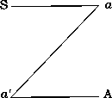
-- double narcissism (I=ego [Imaginary ideal ego], I=other [ego ideal]) in the mirror stage and the Symbolic (pp. 15);
-- fading subject, in a process of splitting (I=ego [Imaginary ideal ego]/mother as other, I=other [ego ideal]/Other) pp. 19, 22-
-- the Imaginary, as dominated by “Desire of Mother,” experienced by a baby at its mirror stage; objet petit a
-- the Symbolic Order, or Language as dominated by “Nom du Pere”
-- the Real as crude reality over which the Symbolic and the Imaginary seek to control;
2. To be more specific, do you agree with the process of subjectivity as described by Lacan (including the ideas of double inscription of subjectivity, narcissism, “Desire of Mother,” “Nom du Pere,” and the sense of Imaginary plenitude as well as lack?
3. According to Wright (2000 67), Lacan moves beyond the dualism of pleasure principle and reality principle to posit a dialectic of need (for nourishment, the realm of the real), demand (for mother’s absolute love, in the Imaginary) and desire (for a fantasy, the traces of a lost object in the symbolic). Do you agree with this view?

The Insistence of Language:
- Lacan distinguished from Freud pp. 7-8;
- How Lacan uses and revises Saussure’s algorithm p. 9;
- S/s defined and explained pp. 10-11;
- mirror stage S and the Oedipus complex and entrance into the Symbolic S ◊ a ( pp. 12-14)
- double narcissism;
- the Phallus as the mediating third term and/or the figure of judge, ruler, arbitrator, and the authority (p. 17; p. 29)

II. The Structure of Lacanian Thought
Figure 1: pp. 20-21 The Sign = s l S The Subject I l Other (double movement; l can mean both mirror and language)
Figure 3: metaphor as knowledge/repression process and metonymy as desiring process pp. 24-
Figure 5: an overall view, combining Freud’s p. 27
* Castration and the Phallus p. 29
* an economic view of Lacan’s concept of subjectivity p. 30
Borromean knot
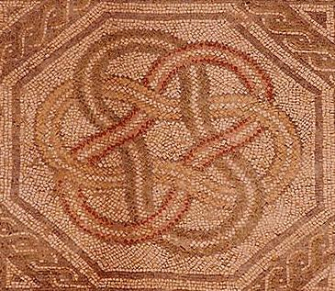


source: http://www.workingforchange.com/comic.cfm?itemid=15540
- Mellard, James M. “Introduction.” Using Lacan, Reading Fiction. U of Illinois P, 1991.
- Wright, Elizabeth. Psychoanalytic Criticism: A Reappraisal. Polity Press, 1998.
- ---. Speaking Desires Can Be Dangerous: The Poetics of the Subconscious. Polity Press, 2000.
* another example of Lacan’s algorithm http://www.dnafoundation.com/priv/models.htm

