Roland Barthes:
From Structuralism to Post-Structuralism
Mythologies (1957) & “From Work to Text”
※ Starting Questions
※ Introduction: Roland Barthes and Semiotics
※ ”The Myth Today”
※ Excerpts from Mythologies
※ “From Work to Text”

※ Starting Questions
1) What is semiotics? How do we do semiotic reading of literature and the other cultural products? (How do we do a structuralist reading of narrative? Next time, we’ll try them on “The Yellow Wallpaper” http://etext.virginia.edu/toc/modeng/public/GilYell.html, or a text of your own choice) Are there advantages or problems in reading everything as signs, or floating signifiers?
2) How does Barthes define “myth today”? How is it different from the way Levi-Strauss define mythology? Is there a way to connect these two concepts?
3) How does Barthes distinguish between work and text? How does this distinction determine our ways of reading?
4) What are the differences between structuralism and post-structuralism? Where do we see in our reading of Levi-Strauss and Barthes traces of poststructuralism?

※ Introduction: Roland Barthes and Semiotics
-- Roland Barthes: General Introduction: http://www.eng.fju.edu.tw/Literary_Criticism/deconstruction/barthes.html

-- Semiotics: a Science of Signs
Major influences: 1) Ferdinand de Saussure
2) Charles Sanders Peirce: index, icon and symbol; “He eventually defined semiosis as an ‘action, or influence, which is, or involves, a cooperation of three subjects, such as a sign, its object, and its interpretant.” (http://en.wikipedia.org/wiki/Charles_Peirce )
3) Roland Barthes: “the sign becomes a signifier of another sign, a connotation, or second order sign, which signifies a cultural value, such as status. In this case the sign becomes a “sign vehicle” for the connotative aspects of cutlure, such as the status structure of society” (Gottdiener 15).
4) post-structuralist semiotics: e.g. a. Roland Barthes’ S/Z, breaking a text "Sarrassine" in terms of 5 codes into a number of lexias. (Later today: “From Work to Text”)
b. Derrida – for polysemy and against logo-centrism (or transcendental signified) and one-to-one correspondence between signifier and signified. Signs are always open to interpretation (connection with another signified).
c. Jean Baudrillard – hyperreality= reproducible signs. [Image] “bears no relation to any reality whatever: it is its own pure simulacrum.”
d. Socio-Semiotics: (Gottdiener 25-). i) Socio-semiotics accounts for the articulation of the mental and the exo-semiotic, the articulation between the material context of daily life and the signifying practices within a social context.”
ii) [All] meaning arises from this more articulated, codified dimension. The principal epistemological position of socio-semiotics is that connotation precedes denotation. Both the produced object world itself and our understanding of it derives from codified ideologies that are aspects of social practice and their socialization processes.”
iii) Signified still exists. Meanings are themselves grounded in everyday life experience.
iv) Signs are really sign vehicles that constitute the media of social interaction.

※ ”The Myth Today” (excerpt: http://carbon.cudenver.edu/~mryder/itc_data/barthes/myth_today.html )
Main Idea: Today’s Myth is a type of speech, a semiological (tiered) system of communication, which distorts reality and makes its distortion natural, while putting history under erasure. Myth is depoliticized, a way of justifying the bourgeoisie.

I.Myth is type of speech, a system of communication
a type of speech; a system of communication(109), a mode of signification, “not defined by the object of its message but by the way in which it utters this message.”(109)

II.Myth as a semiological system (111)
A. Semiology is a science of forms, since it studies significations apart from their content. "a little formalism turns one away from History, but that a lot brings one back to it." (111)
-- Semiology distinguished from Formalism (112);
Semiology is open to historical and ideological studies. “[T]he more a system is specifically defined in its forms, the more amenable it is to historical criticism.”

III. Three terms: signifier, signified and sign (form, meaning/concept and process of signification)--the signifier is empty, the sign is full (113)
We must here be on our guard, for despite common parlance which simply says that the signifier expresses the signified, we are dealing, in any semiological system, not with two, but with three different terms. (113)
e.g.(113) rose as a sign ...on the plane of experience I cannot dissociate the roses from the message they carry, as to say that on the plane of analysis I cannot confuse the roses as signifier and the roses as sign.
e.g. (113)black pebble as a signifier can signify in several ways (death sentence, etc)
signifier/signified/sign: signifier empty, sign full
Related. three terms
Freud’s three terms: manifest content of behavior, latent content and dream as a sign (114)
Sartre: crisis, literature as discourse, signification

IV. The formation of myth (p. 114-)
-- Myth as “a second-order semiological system,” where the sign of the first order becomes a signifier of the second.
-- The two semiological levels of myth:
LANGUAGE  MYTH
  1. Signfier | 2. Signified
  3. Sign  I. SIGNFIER |  | II. SIGNIFIED
  III. SIGNS
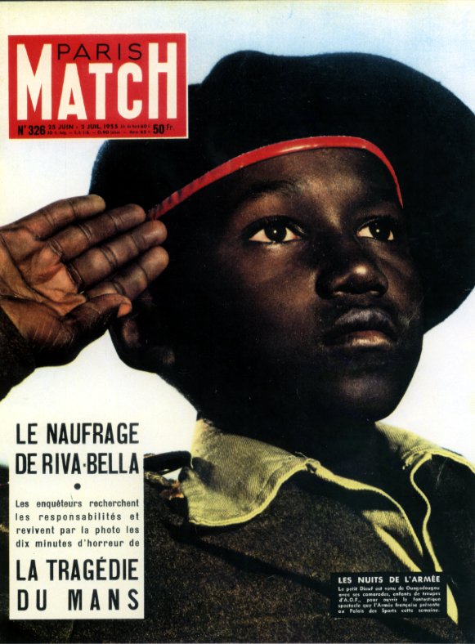
1) the linguistic system as language-object
2) myth as metalanguage
Two examples 1) “because my name is lion” –part of a first semiological system;
“[T]here is a signified and there is a global signification, which is none other than the correlation of the signifier and the signified.” (116)
2) a young negro saluting the tricolour (116-17)→ Frenchness and militariness
※ questions: examples? Your interpretation?
The form and the concept
1) first-order meaning full on one side and empty on the other:
The signifier of myth presents itself in an ambiguous way: it is at the same time meaning and form, full on one side and empty on the other. As meaning, the signifier already postulates a reading...it has a sensory reality...As total of linguistic signs, the meaning of the myth has its own value, it belongs to a history, that of the lion or that of the Negro: in the meaning, a signification is already built, and could very well be sufficient if myth did not take hold of it and did not turn it suddenly into an empty, parasitical form. (117)
2) second-order: history erased, in a hide-and-seek game.
i) When it becomes form, the meaning leaves its contingency behind; it empties itself, it becomes impoverished, history evaporates, only the letter remains.--regression from meaning to form, from the linguistic sign to the mythical signifier. ..
ii) .(p. 118) the form does not suppress the meaning, it only impoverishes it, it puts it at a distance... Constant game of hid and seek defines myth (→ This leaves room for the critic’s decoding.)
iii). History—“the motivation which causes the myth to be uttered.” (118)
iv) Myth: A signified can have several signifiers--true for linguistics, psychoanalysis, and myth. (120)

V. The signification of Myth (121-) ※ questions: examples?
A. To distort not to disappear (obliteration) -- myth hides nothing: its function is to distort, not to make disappear
...[myth] transforms history into Nature....for the myth reader...everything happens as if the picture naturally conjured up the concept, as if the signifier gave a foundation to the signified...

B.The idea of alibi (123) “It is enough that its signifier has two sides for it always to have an ‘elsewhere’ at its disposal.” e.g. window view and windowpane; glass and landscape→ “its form is empty but present, its meaning absent but full.
C. (124) Myth as an interpellation speech: “Myth has an imperative, buttonholing character: ...it is I whom it has come to seek. ...
D. 125) Myth as a frozen speech: “For this interpellant speech is at the same time a frozen speech: at the moment of reaching me. It suspends itself, turns away and assumes the look of generality: it stiffens, it makes itself look neutral and innocent.” E.g. The idea about "Arrest" “The Negro’s salute thickens, …freezes into an eternal reference meant to establish French imperiality.”
E. (126)
its motivation The mythical signification...is never arbitrary; it is always in part motivated, and unavoidably contains some analogy. Fragmentary, not natural. “It is history which supplies its analogies to the form.” (partial analogy between meaning and form.)

VI. Reading and deciphering myth (127-)
[1. producer of advertisement; 2. critic; 3. reader/consumer of advertisement]

A. To act like a producer of myth, or Journalist
If I focus on an empty signifier, I let the concept fill the form of the myth without ambiguity, and I find myself before a simple system, where the signification becomes literal again: the Negro who salutes is an example of French imperiality, he is a symbol for it. This type of focusing is ..that of the producer of myths...

B. To act like a Mythologist (or a Critic, a decoder)
If I focus on a full signifier, in which I clearly distinguish the meaning and the form, and consequently the distortion which the one imposes on the other, I undo the signification of the myth, and I receive the latter as a imposture: the saluting Negro becomes the alibi of French imperiality.

C. To act like a Myth Reader
Finally, if I focus on the mythical signifier as on an inextricable whole made of meaning and form, I receive an ambiguous signification...I become a reader of myths. The saluting Negro is no longer an example or a symbol, still less an alibi: he is the very presence of French imperiality.

* comparison: The first two types of focusing are static, analytical; they destroy the myth, either by making its intention obvious, or by unmasking it: the former is cynical, the latter demystifying. The third type of focusing is dynamic, it consumes the myth according to the very ends built into its structure: the reader lives the myth as a story at once true and unreal.

pp. 129 – the differences between a decoder and a consumer: 1) Myth aims at causing immediate impression. 2) myth is experienced as innocent speech.
※ questions: signs of naturalization?

VII.Myth as a stolen language
A. Language- robbery (in transforming meaning into form)
B.Nothing is safe under the threatening of myth (131)
1. Even nonsence is not a zero degree, and it can still lend itself to myth;
2. Everything is open to interpretation, and thus mythologization.
3. Even mathematic formula can be turned into a pure signifier of Mathematicity
4. Classical poetry—also open to myth;
Exceptions:
-- contemporary poetry –regressive semiological system (a movement from form/sign back to meaning. P. 133)
-- p. 135 reduction of literature into a simple semiological system

VIII.The bourgeoisie as joint- stock company
1. Bourgeoisie – the class that does not want to be named. They merge into the nation, their ideology spread over everything.
2. revolts against bourgeoisie: the avant-garde
e.g. Example: the big wedding 141

IX. Myth is de-politicized speech
A. Marx: the most natural object contains a political trace
B. Myth: to clarify, naturalize, and to fabricate (143)

X.Myth on the left ※ questions: do you agree?
A. Revolution vs. myth
There is a language which is not mythical: the language of man as a producer: wherever man speaks in order to transform reality and no longer to preserve it as an image, wherever he links his language to the making of things, meta-language is referred to a language-object, and myth is impossible.

Revolution is defined as a cathartic act meant to reveal the political load of the world: it makes the world; and its language, all of it, is functionally absorbed in its making. (146)

B. Left-Wing Myth is inessential. (p. 147) It does not penetrate our everyday life.

C. Left-Wing Myth is poverty-stricken, lack fabulizing faculty; lack the variety of signifier “The speech of the oppressed can only be poor, monotonous, immediate” (148).

D. p. 148 unable to throw out the real meaning of things, to give them the luxury of an empty form.

XI.Myth on the Right
A. It is essential, well-fed, sleek, expansive, garrulous, it invents itself endlessly. It takes hold of everything (p. 148).
e.g. the myth of Childhood-as-Poet

B. The principle figures –
1.The inoculation –admitting accidental evil to conceal its principal evil
2.The privation of history
3.Identification – unable to imagine the Other.
4.Tautology –“just because, that’s all” → betrayal of rationality and language/
5.Neither- Norism – One flees from an intolerable reality, reducing it to two opposites.
6.The quantification of quality –quantification of effects
7.The statement of fact – universalism and refusal of any explanation

XII. Necessity and Limits of Mythology—the positions of the mythologist
- Mythologist tries to find alienation under the guise of innocence.
- However, his task remains ambiguous. He can live revolutionary acts only vicariously.
- He runs the risk of causing the reality he purports to protect to disappear.
- What we must seek: a reconciliation between reality and men, between description and explanation, between object and knowledge.

※ Excerpts from Mythologies
Liquid Detergent vs. Power
The Brain of Einstein
Photography and Electoral Appeal

References:
-- Mythologies Tony McNeill’s lectures http://orac.sund.ac.uk/~os0tmc/myth.htm
Gottdiener, Mark. Postmodern Semiotics: Material Culture and the Forms of Postmodern Life. Maiden, MA: Blackwell, 1995.

