Let's Learn English with

Winnie-the-Pooh !!!
  Cook With Pooh  Play With Pooh | 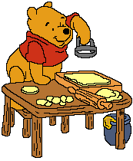 | Read With Pooh  Sing With Pooh

