
研究生學習規劃與記錄
Graduate Study Plan and Record
The purpose of this form is to facilitate advising by keeping the department informed of M.A. students' study plans and progress toward their degrees. The form should be updated at the end of each semester and whenever new information is available. Students may make changes to their study plans, in consultation with their advisors, whenever necessary.
Required credits for graduation: 30 credits(not including thesis credits);
Total Credit No. Finished: (last updated: )
1st year Advisor:
2nd year Advisor:
3rd year Advisor:

Student No. |  | Name | (Chinese)  (English)
★ Courses Taken |  |  |  | Credits | Finished  ☑
★ OTHER ELECTIVE COURSES (outside the department)
Course | Dept/School | Credits | Finished  ☑
★ OTHER ELECTIVE COURSES (non-graduation credits)
Course | Dept/School | Credits | Finished  ☑
★ MAJOR, MINOR/Conference and Multimedia Project 主修學科考、副修規定與多媒體製作
呈現 以下option (1) and option (2)擇一填寫，沒有填寫的就不呈現。
Literature Track：
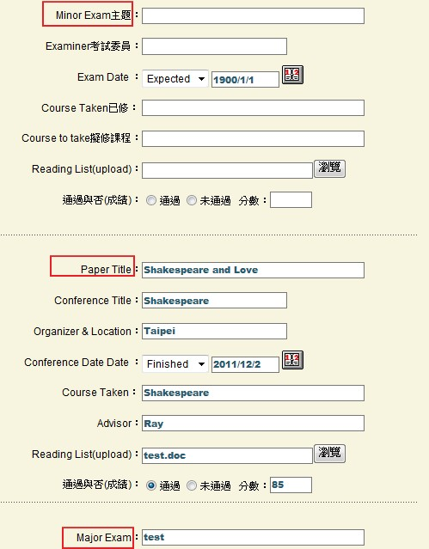
Minor Option (2): Paper Presentation
Paper (upload) 見下文
分數由系辦登錄
Minor Option (1): Exam
Literature Track (1) Minor option (1)
Exam:主題
Examiner:考試委員 |  | (Expected) Exam Date
Course Taken: 已修
Course to take 擬修課程

Literature Track (2) Minor option (2)
Paper Title
Conference Title
Organizer & Location |  | (Expected) Presentation Date
Advisor
Related Course(s)
Paper | (upload 上傳)
Reflections | (upload 上傳)

Literature Track (3) 主修考試 Major Exam
Major Exam
Examiner: |  | (Expected) Exam Date
Courses Taken:
Courses to take

Multimedia Track
Conference Participation (1)
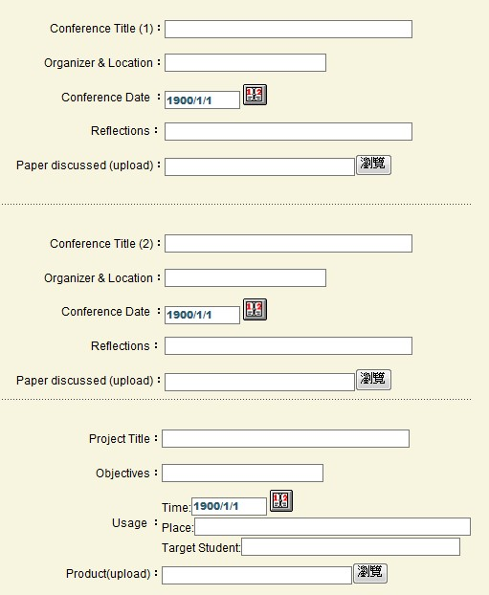
Conference Program or Proceedings
Conference Participation (2) optional
上傳

Multimedia Track
Conference Participation (1)
Conference Title
Organizer & Location |  | Conference Date
Reflections | (upload)
Conference Program or Proceedings | (upload)

Conference Participation (2) Optional
Conference Title
Organizer & Location |  | Conference Date
Reflections | (upload)
Conference Program or Proceedings | (upload)

Conference Presentation (optional)
Conference Title
Organizer |  | Conference Date
Reflections | (upload)
Paper (upload 上傳) | (upload)

Multimedia Track (2): Multimedia Project

Project Title
Objectives
Usage | __ Proposed Usage __ Actual Usage  Time:  Place:  Target Student:
Advisor Approval | Date:
★ THESIS 論文
SUBJECT
(Possible)
ADVISOR 指導教授
(Possible) （可能）
考試委員
Committee Members
Courses Taken:
Courses to be Taken:

Application Date:
(Expected) Exam Date:
Score

