Contemporary Canadian Film & Literature:  
Survival
in Postmodern Cities
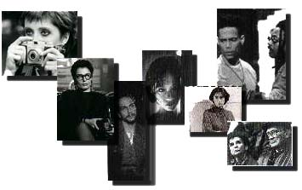
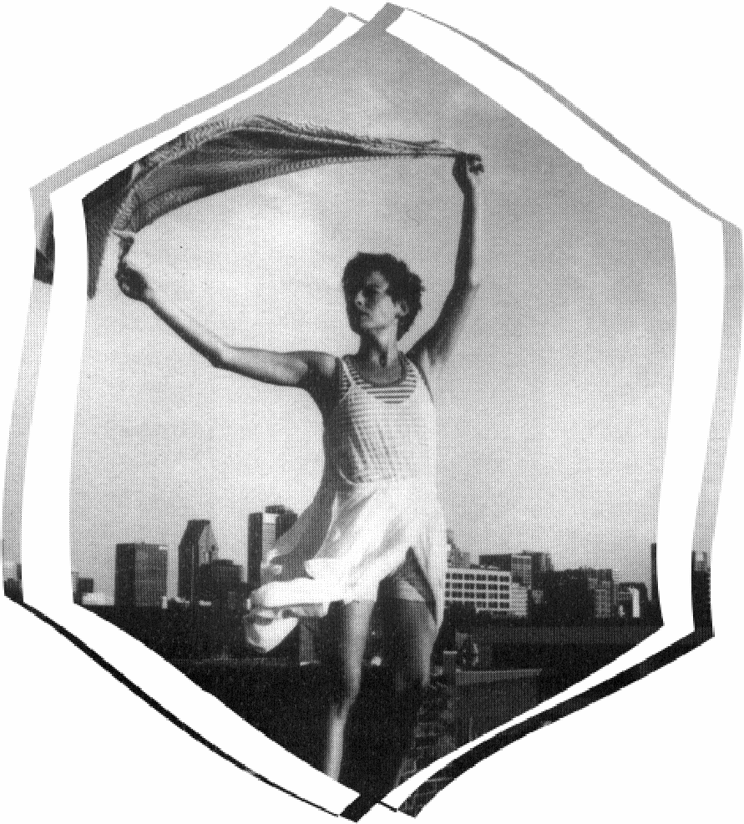
Kate Liu, Fall, 2001

Greater Toronto Area
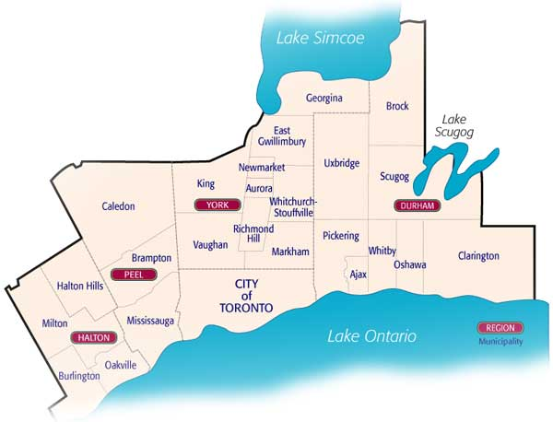
Toronto’s & Montreal’s Locations:

Toronto City Map 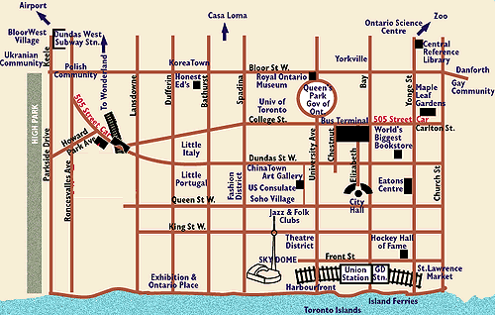
Montreal City

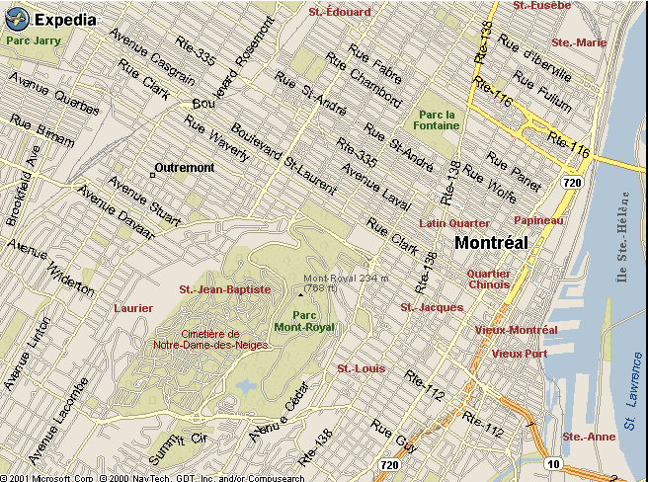
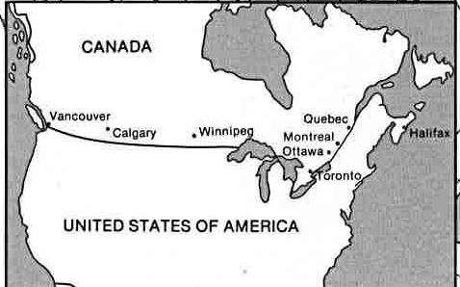
Table of Contents
Title and author | source | p
History and Overviews:  (Montreal) "The Street That Got Mislaid"  Patrick Waddington | 1. | 1
In the Skin of a Lion ("Little Seeds" & "The Bridge") Michael Ondaatje | 2. | 4
Race Relations:  (Montreal) "Piety" (Jewish) Irving Layton | 1 | 26
(Montreal) "North" (Canada-US) Clark Blaise | 1 | 34
(Montreal) "Snakebite" (English-French) Ann Diamond | １ | 44
"The Immaculate Conception of Photography Gallary" | 3 | 51
(Toronto) "I'm Running for my Life"  (Barbado) Austin Clarke | 4 | 57
(Toronto) "At the Lisbon Plate"  (Trinidad) Dionne Brand | 5
(Montreal) "Pigeon in Lemon Sauce"  (Haiti) Dany Laferriere | 6
* See the end of the textbook for the sources.
Love and Obsession:  The Robber Bride (“Onset” & "Robber Bride") Margaret Atwood | 8
"Under the Wings of a Big Old Bird"  Stuart Ross | 6
"Topographies" Natasha Waxman | 6
Artists’ Views:  "In Various Restaurants" Daniel Jones | 6
Chance Encounter  “Crates of Stars" Golda Fried | 6
"Rescue" Cordelia Strube | 6
Other Stories for your pleasurable reading:
Chance Encounter  “Missing” Julie Doucet  “A Kiss is Still a Kiss” Barry Callaghan |  | 6  3
Childhood: (Montreal)  "Lies My Father Told Me"(Jewish) Ted Allan |  | 1
Love and Obsession: Necrophilia  (Toronto) "We So Seldom Look on Love" by Barbara Gowdy |  | 3
Artist’s Views (Montreal) “The Big Killer” Murray Smith |  | 1
Sources:
- Montreal mon amour: short stories from Montreal. Ed. Michael Benazon. Toronto: Deneau, 1989.
- Ondaatje, Michael. In the Skin of a Lion. Toronto: Penguin, 1987.
- This Ain't No Healing Town: Toronto Stories. Ed. Barry Callaghan. Toronto: Exile, 1995.
- Clarke, Austin. In This City. Toronto: Exile, 1992.
- Brand, Dionne. Sans Souci and Other Stories. Toronto: Women’s Press, 1989
- Concrete Forest: The New Fiction of Urban Canada. Ed. Hal Niedzviecki. Toronto: M & S, 1998.
- Atwood, Margaret. The Robber Bride. Toronto: McClelland-Bantam, Inc., 1993.
Michael Ondaatje

In the Skin of a Lion
The novel begins with a curious and intimate remembrance of childhood obsessions and embedded images. And like the memories of a child, the story that unfolds doesn't tell us all the expected facts in a linear fashion. . . .
Patrick Lewis leaves the Canadian wilderness for Toronto in the 1920's. He seems to have no specific course for his life and wanders among the city's working class like an Englishman exploring the Amazon jungle. He immerses himself in the life of each tribe he comes to until something propels him to move on. This is a mythic and stylized version of Canadian history, as if working class revolutionaries had really won their struggles, becoming the conquering heroes who chose what version of their stories went into the history books. The attention lavished on the details of various trades—bridge builders, leather tanners--doesn't seem unusual in this context. The laborers are noble and exotic: a thief is a shaman, the baker, a hero. http://www.mashmagazine.com/00feb/febbook.htmlhttp://www.mashmagazine.com/00feb/febbook.html

Patrick雖是土生土長的加拿大人，但家境窮困，幼時住在地圖沒有畫到的區域﹙10﹚。在成長過程中，他先身處鄉野，後「移民」到多倫多﹐再慢慢走入社會地圖的邊緣，認識社會剝削勞工的事實，最後並加入抵制權力的活動。派翠克進入多倫多社會的經驗大致可分三種︰他的勞工工作、搜尋工作、和戀愛經驗；三種經驗交錯，使他慢慢開放自己，同情勞工，並加入他們。

The joyful will stoop with sorrow, and when
you have gone to the earth I will let my hair
grow long for your sake, I will wander through
the wilderness in the skin of a lion.

THE EPIC OF GILGAMESH

Never again will a single story be told
As though it were the only one.

JOHN BERGER
The Robber Bride

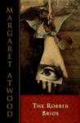 by MARGARET ATWOOD

Synopsis
This is the wise, unsettling, drastic story of three women whose lives share a common wound: Zenia, a woman they first met as university students in the sixties. Over the course of 30 years, she damaged each of them badly, betrayed their trust and treated their men as loot; then died. As the book opens, Zenia reappears in the restaurant where the three friends are eating lunch. In a richly layered narrative, Atwood skillfully evokes the decades of the past as she reveals the dark, sometimes chilling aspects of her characters’ childhoods. She retraces their lives, including their catastrophic encounters with Zenia, until we are back in the present — where it’s yet to be discovered whether Zenia can still wreak havoc.

Our excerpts and the book’s section titles (excerpts underlined):

- Onset pp. 1-4 Zenia in history and the ”present” of the novel: Oct 23, 1990
- The Toxique – Tony, Charis and Roz meeting in Toxique, seeing Zenia by accident. (The story told respectively from the three characters’ perspectives.)
- Black Enamel – Tony’s childhood and her experience with Zenia
- Weasel Nights – Charis’s
- The Robber Bride –Roz’s
Chap 39: (Oct 23, 1990) Roz in her office and back home after meeting Zenia.
Chap 40: (May 1983) Roz and her husband Mitch
Chap 41: Roz and Mitch’s knowing each other and their marriage. (May 1983) p. 354 – meeting Zenia
Chap 42: Roz’s childhood with her mother in their rooming house. Her school’s Catholic education.
Chap 43: Roz’s father back from WWII. Roz getting to know about anti-Semitism.
Chap 44: the Father’s mistresses and his getting rich. Roz takes on a Jewish identity. Roz as a hybrid (388-90).

Chap 45: Roz after marriage, finds out about her father’s money. Roz, WiseWomanWorld and Mitch. (May 1983) Why she wants to meet Zenia again.
Chap 46: (May 1983) meeting Zenia. P. 404 Zenia’s stories
Chap 47: Zenia joins WiseWomanWorld. Mitch’s betrayal and Zenia’s disappearance p. 418-.
Chap 48 Mitch’s return. 1986 March Zenia’s death and then Mitch’s. Roz’s nervous breakdown.
Chap 49: (Oct 23, 1990) Roz on the cellar floor and then back up to the living room, comforted by the twins.
- The Toxique: the three women go to meet Zenia respectively, facing her challenges (seduction and denial). Zenia’s death.
- Outcome
Natasha Waxman
An ex-Canadian, ex-secretary, ex-waitress, ex-banana cultivator, ex-international child traumatizer, ex-tooter, and ex-enumerator, Natasha Waxman is presently a Michener Fellow pursuing an MFA in creative writing from the Texas Center for Writers. (source: http://www.utexas.edu/cola/depts/lac/XX/bios/waxman.html )

