DISCUSSION QUESTIONS ON UNCLE TOM”S CABIN
1. Tom has been brought up on charges in the court of public opinion, and you have been part of his defense team. Write a summation to the jury, defending Tom against the charge that he is an “Uncle Tom”—that is, “fawning and servile in his behavior to whites.” Stress any points in Tom’s experience, behavior, and / or philosophy that seem to you to be relevant in his defense.
2. Simon Legree has been charged with Tom’s murder. You considered resigning from your law firm, which Legree hired to defend him, but your boss talked you out of it. Now you have been assigned to write a brief explaining why Legree should be convicted of a lesser charge. Write an essay in which you present any evidence and / or logical arguments you can find to support the idea that, considering Legree’s culture and the circumstances surrounding Tom’s death, Legree should not be charged with capital murder.
3. Compare and / or contrast any two characters in Uncle Tom’s Cabin who seem to you to present an interesting opposition or likeness (for example, Chloe and Cassy, Mrs. Shelby and Marie St. Clare, Haley and Legree, Topsy and Eva, etc.). Focus on three or four points (character traits, important influences, effects on other characters, and so on) that seem to you especially characteristic of your choices.
4. Discuss how (or even whether) Uncle Tom’s Cabin might be dramatized and presented in a modern production (in whole or in part) without offending modern audiences.
Reading Questions
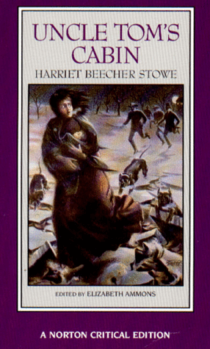 | 1) Think about the cultural life of this book. Even if you haven't read it before, you know about it in some sense, have seen, heard, or read some version of it (the phrase "Uncle Tom," for example). What are the different version of Uncle Tom that you know of? How do they match up with the novel? How do they affect your reading of the novel?  2) Think about the symbolic geography of the novel. How and why various locations mean.  3) Economics plays a pervasive role in the novel. What is Stowe's critique of the economic structure of her society? What does she propose as an alternative?  4) What is the ideological value of emotion in the novel? What role does emotion play in the novel's design? in its designs on the reader? What were your emotions as you read the novel?  5) What is Stowe's theory of history?  6) Why should we (shouldn't we) read this racist, sentimental, popular novel?

