Natty as Frontiersman
In writing The Pioneers, Cooper both addresses and establishes the emerging American identity, still undefined in its infancy. While witnessing the definition of the new American man evolve and solidify, Cooper attempts to guide his development. As a torchbearer of American history, Cooper saw the frontiersman as a dying breed; men caught between two worlds without a home.
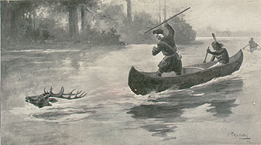
Cooper's construction of Natty Bumppo reflects the author's appreciation of the frontiersmen and his lament of their passing. Natty Bumppo is the literary bridge between the "old world" and the dawning of American possibility. Literary critic James Wallace notes that "Natty always appears from and returns to the forest which surrounds Templeton; he is a socially marginal character in a literal as well as a moral sense" (143). Natty's interactions both in the woods and in civilization make him a vestige of the natural man that Cooper so admires, trapped in the changing world that Cooper bemoans.
Several scenes in The Pioneers reflect specifically Cooper's portrayal of Natty as the American frontiersman. Described and assessed in Leatherstocking as Myth and Symbol, the deer ambush in Chapter I, the hunting incident at Ostwego Lake in Chapters XXVI and XXVII, and the scene at Chingachgook's grave in Chapter XLI are three examples of Natty's characterization as such.
The conclusion of The Pioneers finds Natty devestated by the loss of his best friend, Chingachgook. Turning to his protege, Oliver, and Oliver's wife, Elizabeth, "the old hunter standing looking back for a moment, on the verge of the wood...caught their glances...drew his hard hand hastilly across his eyes again, waved it on high for an adieu, and, uttering a forced cry to his dogs, who were crouching at his feet, [he] entered the forest." In the spirit of a true frontiersman, Natty escapes "the pursuit which Judge Temple both ordered and conducted," and heads "far toward the setting sun-the foremost in that band of pioneers who are opening the way for the march of the nation across the continent."

