Introduction to Literature, Sec B
Handouts Spring, 2011
- Ballad

Western Wind
Western wind, when will thou blow
The small rain down can rain?
Christ, if my love were in my arms
And I in my bed again!
Anonymous
Barbara Allen | 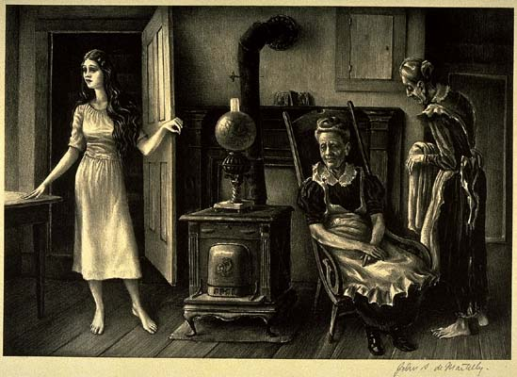
4 versions
Image: deMartelly, John - American (1903-1980) For The Love Of Barbara Allen

Barbara Allen version 1 (from Child’s Ballads 84B)
84B: Bonny Barbara Allen
(source: http://sniff.numachi.com/~rickheit/dtrad/aidx/aidxB.html)
84B.1 IN SCARLET TOWN, where I was bound,
There was a fair maid dwelling,
Whom I had chosen to be my own,
And her name it was Barbara Allen.
84B.2 All in the merry month of May,
When green leaves they was springing,
This young man on his death-bed lay,
For the love of Barbara Allen.
84B.3 He sent his man unto her then,
To the town where she was dwelling:
‘You must come to my master dear,
If your name be Barbara Allen.
84B.4 ‘For death is printed in his face,
And sorrow’s in him dwelling,
And you must come to my master dear,
If your name be Barbara Allen.’
84B.5 your name be Barbara Allen.’
84B.5 ‘If death be printed in his face,
And sorrow’s in him dwelling,
Then little better shall he be
For bonny Barbara Allen.’
84B.6 So slowly, slowly she got up,
And so slowly she came to him,
And all she said when she came there,
Young man, I think you are a dying.
84B.7 He turnd his face unto her then:
‘If you be Barbara Allen,
My dear,’ said he, ’Come pitty me,
As on my death-bed I am lying.’
84B.8 ‘If on your death-bed you be lying,
What is that to Barbara Allen?
I cannot keep you from [your] death;
So farewell,’ said Barbara Allen.
84B.9 He turnd his face unto the wall,
And death came creeping to him:
‘Then adieu, adieu, and adieu to all,
And adieu to Barbara Allen!’
84B.10 And as she was walking on a day,
She heard the bell a ringing,
And it did seem to ring to her
‘Unworthy Barbara Allen.’
84B.11 She turnd herself round about,
And she spy’d the corps a coming:
‘Lay down, lay down the corps of clay,
That I may look upon him.’
84B.12 And all the while she looked on,
So loudly she lay laughing,
While all her friends cry’d [out] amain,
So loudly she lay laughing,
While all her friends cry’d [out] amain,
‘Unworthy Barbara Allen!’
84B.13 When he was dead, and laid in grave,
Then death came creeping to she:
‘O mother, mother, make my bed,
For his death hath quite undone me.
84B.14 ‘A hard-hearted creature that I was,
To slight one that lovd me so dearly;
I wish I had been more kinder to him,
The time of his life when he was near me.’
84B.15 So this maid she then did dye,
And desired to be buried by him,
And repented her self before she dy’d,
That ever she did deny him.

Barbara Allen version 2
(source: http://ingeb.org/songs/barbaraa.html )

Was in the merry month of May
When flowers were a bloomin',
Sweet William on his death-bed lay
For the love of Barbara Allen.
2. Slowly, slowly she got up,
And slowly she went nigh him,
And all she said when she got there,
"Young man, I think you're dying."
3. "O yes, I'm sick and very low,
And death is on me dwellin',
No better shall I ever be
If I don't get Barbara Allen."
4. "Don't you remember the other day
When you were in the tavern,
You toasted all the ladies there
And slighted Barbara Allen?"
5. "O yes, I remember the other day
When we were in the Tavern,
I toasted all the ladies there,
Gave my love to Barbara Allen."
6. He turned his pale face to the wall,
And death was on him dwellin'.
"Adieu, Adieu, my kind friends all,
Be kind to Barbara Allen."
7. As she was walkin' through the fields,
She heard the death bells knelling,
And every toll they seemed to say,
"Hard-hearted Barbara Allen."
8. She looked east, she looked west,
She saw his corpse a-comin'.
"Lay down, lay down the corpse," she said,
"And let me gaze upon him."
9. "O mother, mother make my bed,
O make it long and narrow,
Sweet William died for me today,
I'll die for him tomorrow."
10. Sweet William died on a Saturday night,
And Barbara died on Sunday,
Her mother died for the love of both,
And was buried Easter Monday.
11. They buried Willie in the old church yard,
And Barbara there anigh him,
And out of his grave grew a red, red rose,
And out of hers, a briar.
12. They grew and grew in the old churchyard,
Till they couldn't grow no higher,
They lapped and tied in a true love's knot.
The rose ran around the briar.

Barbara Allen version 3
http://sniff.numachi.com/~rickheit/dtrad/pages/tiBARBALN5.html

It being late, all in the year,
the green leaves they were fallin'
when young Johnny rose from his own country,
fell in love with Barbara Allen.

Get up, get up, her mother says,
Get up and go and see him,
Oh, mother dear, do ye not mind the time
That you told me how to slight him.

Get up, get up, her father says,
Get up and go and see him,
Oh, father dear, do ye not mind the time
That you told me how to shun him.

Slowly, slowly she got up,
and it's slowly she put on her,
Slowly she went to his bedside,
And slowly looked upon him.

You're lyin' low, young man, she says,
And almost near a-dyin'
One word from you will bring me to,
If you be Barbara Allen.

One word from me you never will get,
Nor any young man breathin',
For the better of me you never will be,
Though your heart's blood was a-spillin'.

Look down, look down, at my bed foot,
It's there you'll find them lyin'
Bloody sheets and bloody shirts
I sweat them for you, Allen

Look up, look up to my bed head,
and there you'll find them hangin'
my gold watch and my gold chain
I bestow them to you, Allen

As she was goin' home to her father's hall,
she heard the death-bell ringin'
And every clap that the death-bell gave,
It was "Woe be to you, Allen"

As she was goin' home to her mother's hall,
She saw the funeral comin'
Lay down, lay down that weary corpse,
'Til I get lookin' on 'im

She lifted up the lid off the corpse,
and bursted out with laughin'
and all his weary friends around
Cried "hard hearted Barbara Allen"

She went into her mother's house
Make my bed long and narrow
For the death-bell did ring for my true love today
It will ring for me tomorrow

Out of one grave there grew a red rose
Out of the other a briar
And they both twisted into a true lover's knot,
And there remained forever

Ref. Barbara Allen version 4 (by Art Garfunkel)

All in the merry month of May,
When green buds all are swellin'.
Sweet William on his deathbed lay for love of Barbara Allen.
He sent his servant to the town,
The place where she did dwell in.
Saying, "Master dear has sent me here if your name be Barbara Allen."
Then slowly, slowly she got up and slowly she went to him,
And all she said when there she came was, "Young man, I think you're dying.
"Don't you remember the other night when we were in the tavern?
You drank a toast to the ladies there and slighted Barbara Allen."
He turned his face unto the wall,
He turned his back upon her.
"Adieu, adieu, to all my friends.
And be kind, be kind to Barbara Allen."
As she was wandering on the fields she heard the death bell knellin'.
And every note, it seemed to say,
"Hard-hearted Barbara Allen!"
The more it tolled the more she grieved,
She bursted out a-crying.
"Oh, pick me up and carry me home.
I fear that I am dying."
They buried Willy in the old church yard and Barbara in the new one,
And from William's grave, there grew a rose, from Barbara's, a green briar.
They grew and grew in the old church yard,
Till they could grow no higher,
And there they tied in a true lover's knot,
The red rose and the briar.
William Shakespeare (1564–1616)
Romeo & Juliet | 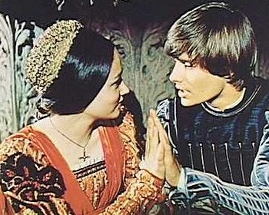
The Courting Sonnet
Image: Romeo and Juliet (1968)

ROMEO AND JULIET, Act 1 Scene 5 ll. 43-52
ROMEO O, she doth teach the torches to burn bright!
It seems she hangs upon the cheek of night
Like a rich jewel in an Ethiope’s ear;
Beauty too rich for use, for earth too dear!
So shows a snowy dove trooping with crows,
As yonder lady o’er her fellows shows.
The measure done, I’ll watch her place of stand,
And, touching hers, make blessed my rude hand.
Did my heart love till now? Forswear it, sight!
For I ne’er saw true beauty till this night.
[. . . ]
(The Courting sonnet -- their first conversation)
ROMEO [To JULIET] If I profane with my unworthiest hand (1)
This holy shrine, the gentle fine is this: (2)
My lips, two blushing pilgrims, ready stand (3)
To smooth that rough touch with a tender kiss. (4)
JULIET Good pilgrim, you do wrong your hand too much, (5)
Which mannerly devotion shows in this; (6)
For saints have hands that pilgrims’ hands do touch, (7)
And palm to palm is holy palmers’ kiss. (8)
ROMEO Have not saints lips, and holy palmers too? (9)
JULIET Ay, pilgrim, lips that they must use in prayer. (10)
ROMEO O, then, dear saint, let lips do what hands do; (11)
They pray, grant thou, lest faith turn to despair. (12)
JULIET Saints do not move, though grant for prayers’ sake. (13)
ROMEO Then move not, while my prayer’s effect I take. (14)
Thus from my lips, by yours, my sin is purged.
JULIET Then have my lips the sin that they have took.
ROMEO Sin from thy lips? O trespass sweetly urged!
Give me my sin again.
JULIET You kiss by the book.

William Wordsworth (1770-1850)
I Wandered Lonely as a Cloud
I wandered lonely as a cloud
That floats on high o'er vales and hills,
When all at once I saw a crowd,
A host, of golden daffodils;
Beside the lake, beneath the trees,
Fluttering and dancing in the breeze.
Continuous as the stars that shine
And twinkle on the milky way,
They stretched in never-ending line
Along the margin of a bay:
Ten thousand saw I at a glance,
Tossing their heads in sprightly dance.
The waves beside them danced; but they
Out-did the sparkling waves in glee:
A poet could not but be gay,
In such a jocund company:
I gazed---and gazed---but little thought
What wealth the show to me had brought:
For oft, when on my couch I lie
In vacant or in pensive mood,
They flash upon that inward eye
Which is the bliss of solitude;
And then my heart with pleasure fills,
And dances with the daffodils.

Percy Bysshe Shelley (1792 – 1822)
Ozymandias
I met a traveller from an antique land
Who said: "Two vast and trunkless legs of stone
Stand in the desert. Near them on the sand,
Half sunk, a shattered visage lies, whose frown
And wrinkled lip and sneer of cold command
Tell that its sculptor well those passions read
Which yet survive, stamped on these lifeless things,
The hand that mocked them and the heart that fed.
And on the pedestal these words appear:
`My name is Ozymandias, King of Kings:
Look on my works, ye mighty, and despair!'
Nothing beside remains. Round the decay
Of that colossal wreck, boundless and bare,
The lone and level sands stretch far away".
John Keats (1795–1821)
“La Belle Dame sans Merci”

I.
O WHAT can ail thee, knight-at-arms,
Alone and palely loitering?
The sedge has wither’d from the lake,
And no birds sing.
II.  O what can ail thee, knight-at-arms! | 5
So haggard and so woe-begone?
The squirrel’s granary is full,
And the harvest’s done.
III.
I see a lily on thy brow
With anguish moist and fever dew, | 10
And on thy cheeks a fading rose
Fast withereth too.
IV.
I met a lady in the meads,
Full beautiful—a faery’s child,
Her hair was long, her foot was light, | 15
And her eyes were wild.
V.
I made a garland for her head,
And bracelets too, and fragrant zone;
She look’d at me as she did love,
And made sweet moan. | 20
VI.  I set her on my pacing steed, | 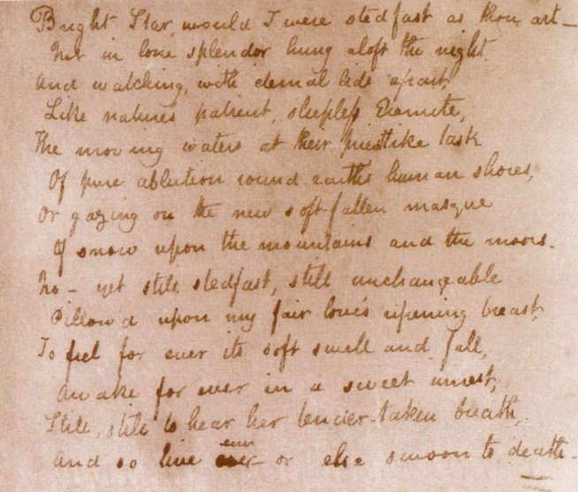  “Bright Star” transcribed by Keats into a volume of Shakespeare  in late September 1820.  (source: Wikipedia “Bright star, would I were steadfast as thou art”  Bright Star  Bright star, would I were steadfast as thou art —  Not in lone splendour hung aloft the night  And watching, with eternal lids apart,  Like Nature's patient, sleepless Eremite,  The moving waters at their priestlike task  Of pure ablution round earth's human shores,  Or gazing on the new soft-fallen mask  Of snow upon the mountains and the moors —  No — yet still stedfast, still unchangeable,  Pillow'd upon my fair love's ripening breast,  To feel for ever its soft swell and fall,  Awake for ever in a sweet unrest,  Still, still to hear her tender-taken breath,  And so live ever — or else swoon to death.
And nothing else saw all day long,
For sidelong would she bend, and sing
A faery’s song.
VII.  She found me roots of relish sweet, | 25
And honey wild, and manna dew,
And sure in language strange she said—
“I love thee true.”
VIII.
She took me to her elfin grot,
And there she wept, and sigh’d fill sore, | 30
And there I shut her wild wild eyes
With kisses four.
IX.
And there she lulled me asleep,
And there I dream’d—Ah! woe betide!
The latest dream I ever dream’d | 35
On the cold hill’s side.
X.
I saw pale kings and princes too,
Pale warriors, death-pale were they all;
They cried—“La Belle Dame sans Merci
Hath thee in thrall!” | 40
XI.
I saw their starved lips in the gloam,
With horrid warning gaped wide,
And I awoke and found me here,
On the cold hill’s side.
XII.  And this is why I sojourn here, | 45
Alone and palely loitering,
Though the sedge is wither’d from the lake,
And no birds sing.

