~ ’s
Four Year Plan
 | Freshman | Sophomore | 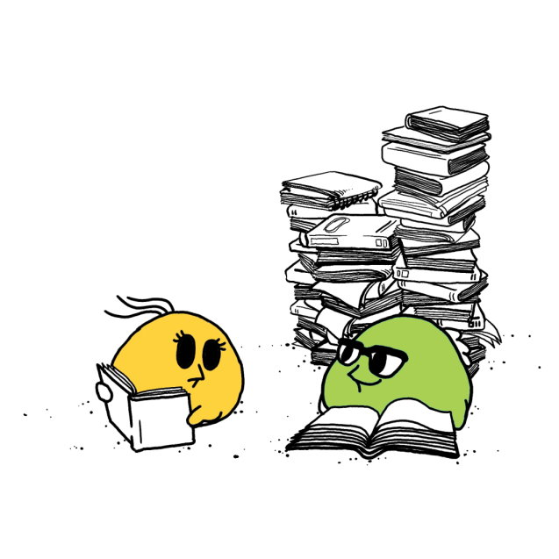
Date of Submission, Revision
& My Emotional Status
(choose from the list below)
 | Junior | Senior | 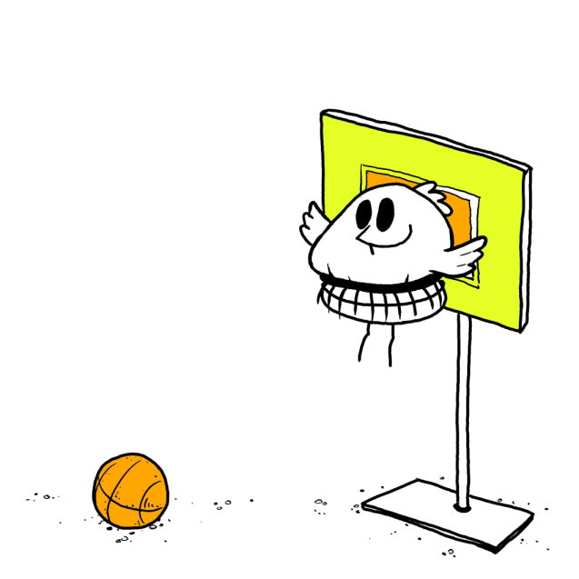
Date of Submission, Revision & My Emotional Status
(choose from the list below)

 |  |  |  |  |  |  |  |  |  | 
not good | ok | questions | overwhelmed | tired | happy | happy in a group | Happy & hardworking | happy and cute | very happy | overjoyed  喜極而泣
目錄
This is YOUR four-year plan; feel free to change the style of this document.

I. Summary 2
(for yearly revision; due each year before the pre-registration in the 2nd semester) 2
A. My Career Objectives and Life Goals 2
B. My University Plan & Steps to carry out the plan 2
C. Credit Check and Total Credit Number 4
D. My Yearly Self-Evaluation 4
II. Assignment for 5
Introduction to University Studies 5

I. Summary
(for yearly revision; due each year before the pre-registration in the 2nd semester)
A. My Career Objectives and Life Goals
1. Summary = please list;
2. Please feel free to delete/change the sample answers below and modify the table.
Objectives | Action | Time/Year - for Action and Accomplishment | Revision
Career (1): Teaching English | - Improving my English (see below) | Freshman-Junior years
Career (1): Teaching English | - Getting a part-time job | School year 103
Career (2): Tourism | - Understanding the career of tourism by going to alumni talk | School year
Career (2): Tourism | - Taking courses and applying for internship in winter | School year
Life (1): Being Healthy and Positive | Going to the gym twice a week | All the time
"Time/year": timing for working on and achieving your objectives
"Action": both intended action and the action already taken.
"Revision": for Sophomore and above

B. My University Plan & Steps to carry out the plan
Please consider the department’s PKS.
BA Professional Knowledge
- 高階英語表達能力 Advanced English Expression Abilities (具有良好的英語聽、說、讀、寫、譯的能力及溝通技巧)
- 文學文化與歷史理解力 Literary, Cultural and Historical Comprehension (具備賞析英語文學與了解其歷史、社會與文化背景之能力)
- 溝通與語言教導Communication and Language Instruction (with background knowledge of general linguistics and applied linguistics) (以相關語言學理論和跨文化溝通理論為基礎，具備溝通與語言教學能力)
BA Professional Skills
(1) 問題分析與解決行為Problem Solving(具有分析、解決問題的能力)To be able to analyze and solve problems
(2) 分析能力分析能力 (具有獨立思考、分析因果的能力) Analytical Thinking (To be able to think independently and analyze causes and effects)
(3) 創新行為Innovativeness具有運用環境觀察力和多媒體及資訊科技之能力發揮創意思考的能力To be able to develop innovative thinking through multimedia competencies and observation of the environment
(4) 研究能力 Research Abilities具備在專業領域深入研究、蒐集並分析資料的能力To be able to do research and analyze data in a professional field of specialization
(5) 國際視野與跨文化溝通能力 Global Perspectives and Cross-Cultural Communication Skills具有國際觀與溝通技巧，能融合多元觀點、尊重不同意見，並能肯定自我In communication, to be able to explain and respect differences from multiple perspectives, especially international ones, while also maintaining confidence in one's own views
(6) 團隊合作行為Cooperativeness樂於與人合作，合作時具有團隊精神，專業倫理 To be able to work with others in a team spirit and with professional ethics

1. Summary = please list;
2. Please feel free to delete/change the sample answers below and modify the table.
Objectives | Action | Time/Year- for Action and Accomplishment | Revision
- PKS: Improving English | - Self-Learning to pass GEPT 中高級複試 | by Aug, 2015
- PKS: Improving English | - Reading newspaper regularly
2) PKS: Developing my knowledge in literature and culture | - Reading two novels a year | Every year
2) PKS: Developing my knowledge in literature and culture | - Going to one museum | Every year
Career Preparation | - Checking my career Interests | 1st year
Career Preparation | - Applying for a minor | 2nd year
Work Experience

C. Credit Check and Total Credit Number
修課檢核表 | Please double-click to open the file and fill out the courses you have taken and passed. Whenever changes are made to this inserted file, don’t forget to save the Word file.  請使用excel檔填入課程，計算學分數，  然後在下表填入學分數。

學分數計算  Credit No. | Freshman  (1st semester) | Sophomore  (1st semester) | Junior  (1st semester) | Senior  (1st semester)
校訂必修課程 (32)
(含外語8)
系訂必修課程(43)
技術訓練課程(22)+
基礎語言文學文化課程(21)
系訂必選課程進階課程(29 + 10) (含進階國文與專業作文各4；語言研究與文學共至少15學分)
其它選修課程 (14)
總畢業學分(128)
Double Major
and/or Minor
Other Types of Learning

D. My Yearly Self-Evaluation
Time/Year
1st year
2nd year
3rd year
4th year

II. Assignment for

Introduction to University Studies
Planning and Enjoying Successful University Years
Four Year Plan Instructions

I. Goal-Setting and Revision
  - My Career Objectives and Life Goals: What will I do after graduation? (based on self-analysis)
    - Jobs/fields I want to explore
    - Professionals and people I would interview
    - My self-understanding and sense of vocation
    - My understanding of reality (e.g. job market)

B. My University Plan
    - English Department courses I shall choose to help myself achieve my goals
    - Courses, minor, double major, or cross-disciplinary programs I would like to take to better prepare myself
    - Job experiences I’d acquire to explore my potential or achieve my goal
    - Volunteer or extra-curricular activities I’d join to enrich my university years and explore my life pursuit
    - Other concrete plans

C. My ways/plans to manage time, take courses (finish a certain number of credits) and achieve my goals
D. My Self Evaluation of the Plan and Follow-up Adjustment (due at the pre-registration period of the 2nd semester of each year)
II. Elaboration: Steps to take to create and revise your four-year plan
A. State your goals clearly, basing on the following
- Self-analysis: interest, aptitude, value, ability
- Understanding of reality
- Summary of background research

B. Provide one to three career proposals

C. Explanation of steps/plan to achieve your goals
- Study Plan in the Department and to enhance your professional knowledge and skills
- Extra courses/programs to take
- Extra-curricular activity plan
- Other related plan

D. Follow-up work: (with a page or two, answer the following questions)
1. What will you do to implement your four year plan? (How do you keep your goals and objectives in mind? When do you revise your plans?)
2. Plan evaluation: Is your four-year plan workable or not? Why is it workable? Which parts are not quite workable and thus may need modification?
3. Do you think you will be able to follow through you plans both for college and for life? Are you willing and able to adapt to changes and modify your plans?

~Have Fun with Your Four-year Plan Explorations~

